 | By: Neil E. Cotter | Probability
 |  | Conditional Probability
 |  | Discrete Random Variables
 |  | Spy game
 |  | Ex 1

Ex: Calculate P{player = yellow | public die = 1 & result = 1 (hit)}
Our intuition from looking at the game board gives the correct answer:
= 2/6
from (# yellows in top row)
To compute these quantities, we consider a space with four axes:
- player color
- public die
- private die
- result
Since we can only draw 3-dimensional figures, we make separate plots to represent the 4th dimension for result = 0 (left plots) and result = 1 (right plots).
The numbers in the boxes in the above plot represent the probabilities of a player picking a certain color, throwing particular numbers on their public and private dice, and announcing a particular result.
If we don't specify a result of a turn, then the player's color, the public die value they throw, and the private die value they throw are independent. For those three parameters, all outcomes are equally likely. Since each parameter has six possible outcomes, the probability of each outcome is 1/6. Since the parameters' outcomes are independent of one another, we multiply their probabilities:
P{player is color x, public die = y, private die = z} = 1/6³.
In contrast to first three parameters, the rules of the game dictate that the result is a deterministic function of the player color, the public die, and the private die. The game board specifies this function:
P{result = 1 | player is color x, public die = y, private die = z} = 0 or 1
There is no uncertainty in the result once the other three parameters are known. Nevertheless, we treat the result as a separate parameter for the purpose of making the above probability plot.
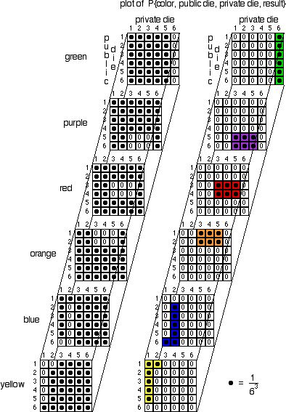
Result = 0 (miss) Result = 1 (hit)

The total probability for all the squares must be 1. Note that, in the probability plot, values in the small squares are either 0 or 1/6³. Furthermore, if a given cube has an entry of 0 for result = 0, it will have an entry of 1 for result = 1, and vice versa.
Thus, we have 2 x 6³ cubes, and exactly half of them contain a value of 1/6³. Our total of all the probabilities equals 1/6³ x 6³ = 1.
Our plot has captured the information on the gameboard, but it does much more. Our plot shows the probability of every possible outcome of a turn in the game. From our plot, we may calculate any probability or conditional probability involving the player's color, public die value, private die value, and result of a turn being 0 or 1 (miss or hit).
Before proceeding to calculations, we consider the plot in more detail.
First, we observe that the player's color, the public die value, and private die value are independent. What color a player chooses doesn't influence what values they will roll on the dice, and vice versa. Also, the value rolled on the public and private die are independent of one another.

