Practice Problems

- A 8 V d.c. voltage source is applied across two parallel plates that are connected in parallel. Each plate has a surface area of 64 X10⁻² cm² . The two plates are separated by 4 cm.

    - Neglecting fringing and assuming free space between the conductors. Find the following:
- The electric field intensity $\overline{E}$
ii) The capacitance between the conductors
iii) The energy stored.

B) If we replace the above coaxial cable with a conductor which is filled with a
dielectric with ε_{r}=2.56 and μ_{r}=1 in the half of the region and with free space in the
remaining area. Find the following:

- The electric field intensity $\overline{E}$
- The capacitance between the conductors
- The energy stored.

- A 8 V d.c. voltage source is applied across the inner and outer conductors of a coaxial pipe with outer radius b=6 cm and inner radius a= 2cm as shown in the figure below. The length of the conductor l=6 cms.
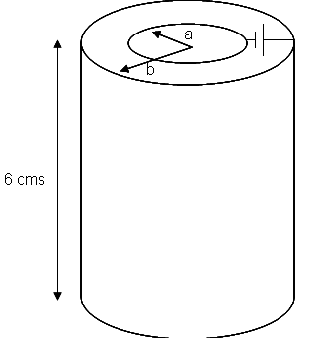

    - Neglecting fringing and assuming free space between the conductors. Find the following:
- The electric field intensity $\overline{E}$
ii) The capacitance between the conductors
iii) The energy stored.

B) If we replace the above coaxial cable with a conductor which is filled with a
dielectric with ε_{r}=2.56 and μ_{r}=1 in the region ($π≤φ≤2π$) and with free space in the
region ($0≤φ≤π$). Find the following:

- The electric field intensity $\overline{E}$
- The capacitance between the conductors
- The energy stored.

3) A plane wave has an electric field given by:

$$E=(\text{30 \{}\hat{x}−\text{40 \{}\hat{z})e^{−j(\text{40}x+\text{30}z)}$$
Find the following:
- The polarization of the wave
- Find wavelength and frequency for wave traveling in the media [ε,μ]= [4ε_{o} ,μ_{o}]
- The corresponding value of H
- The power density
- The phase constant β

4) A plane wave has an electric field given by:

$$E=(\text{10 \{}\hat{x}−\text{20 \{}\hat{y})e^{−j\text{30}z}$$
Find the following:
- The polarization of the wave
- Find wavelength and frequency for wave traveling in the media [ε,μ]= [4ε_{o} ,μ_{o}]
- The corresponding value of H
- The power density
- The phase constant β

5) 6.25
6) 6.27

