Name
Name

UNIVERSITY OF UTAH
ELECTRICAL AND ENGINEERING DEPARTMENT

ECE 5325

WIRELESS TRANSMISSION SYSTEMS

MIDTERM #2

YOU MAY USE A CALCULATOR & PORTFOLIO

NOTE: Erlang B and Q charts are available on the next 2 pages of this exam

April 18,2005

Potentially Helpful Tables and Graphs. If you use these charts, please MARK the places where you obtain your data.

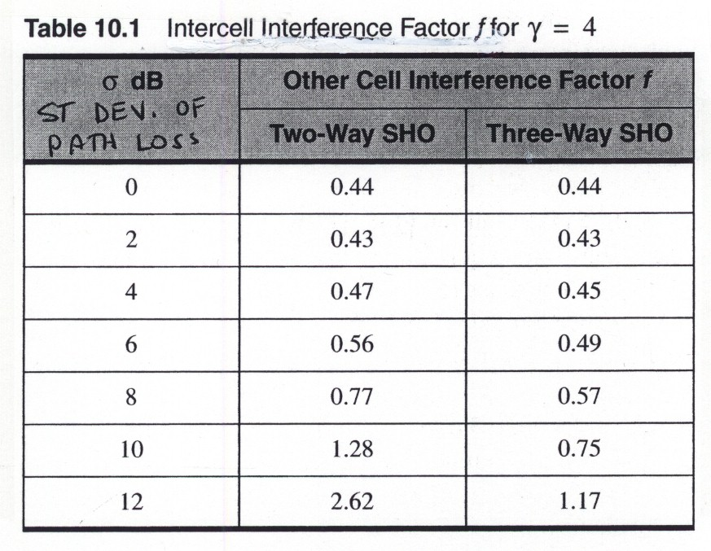
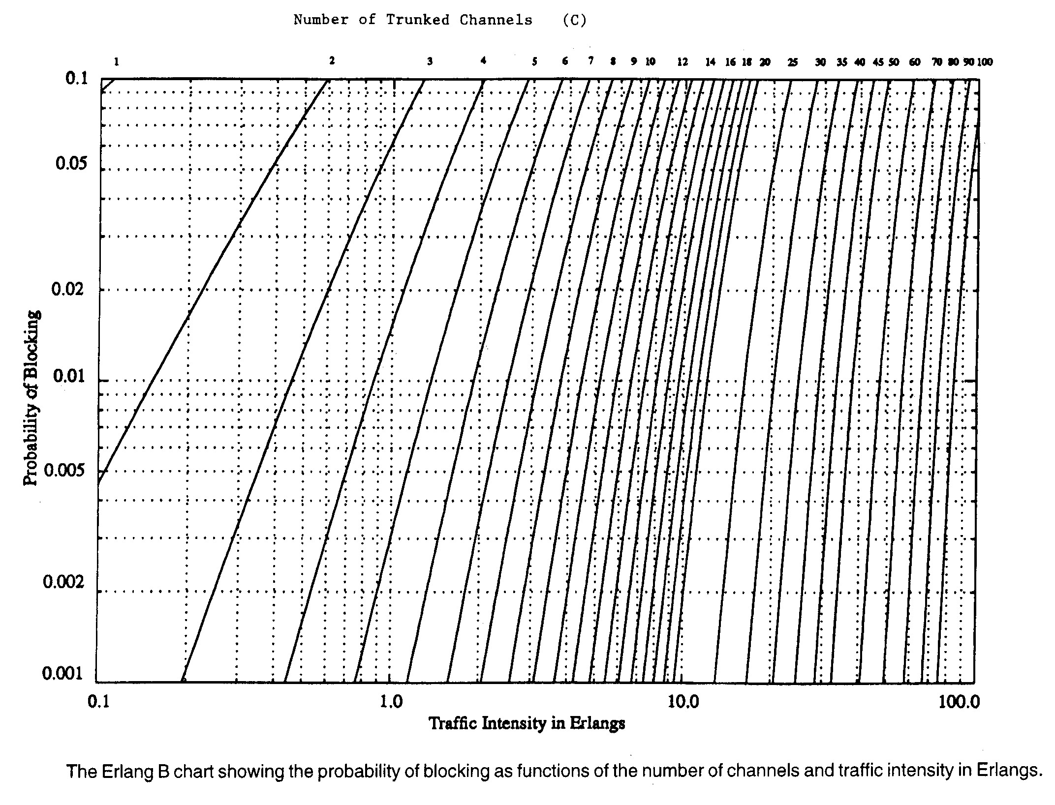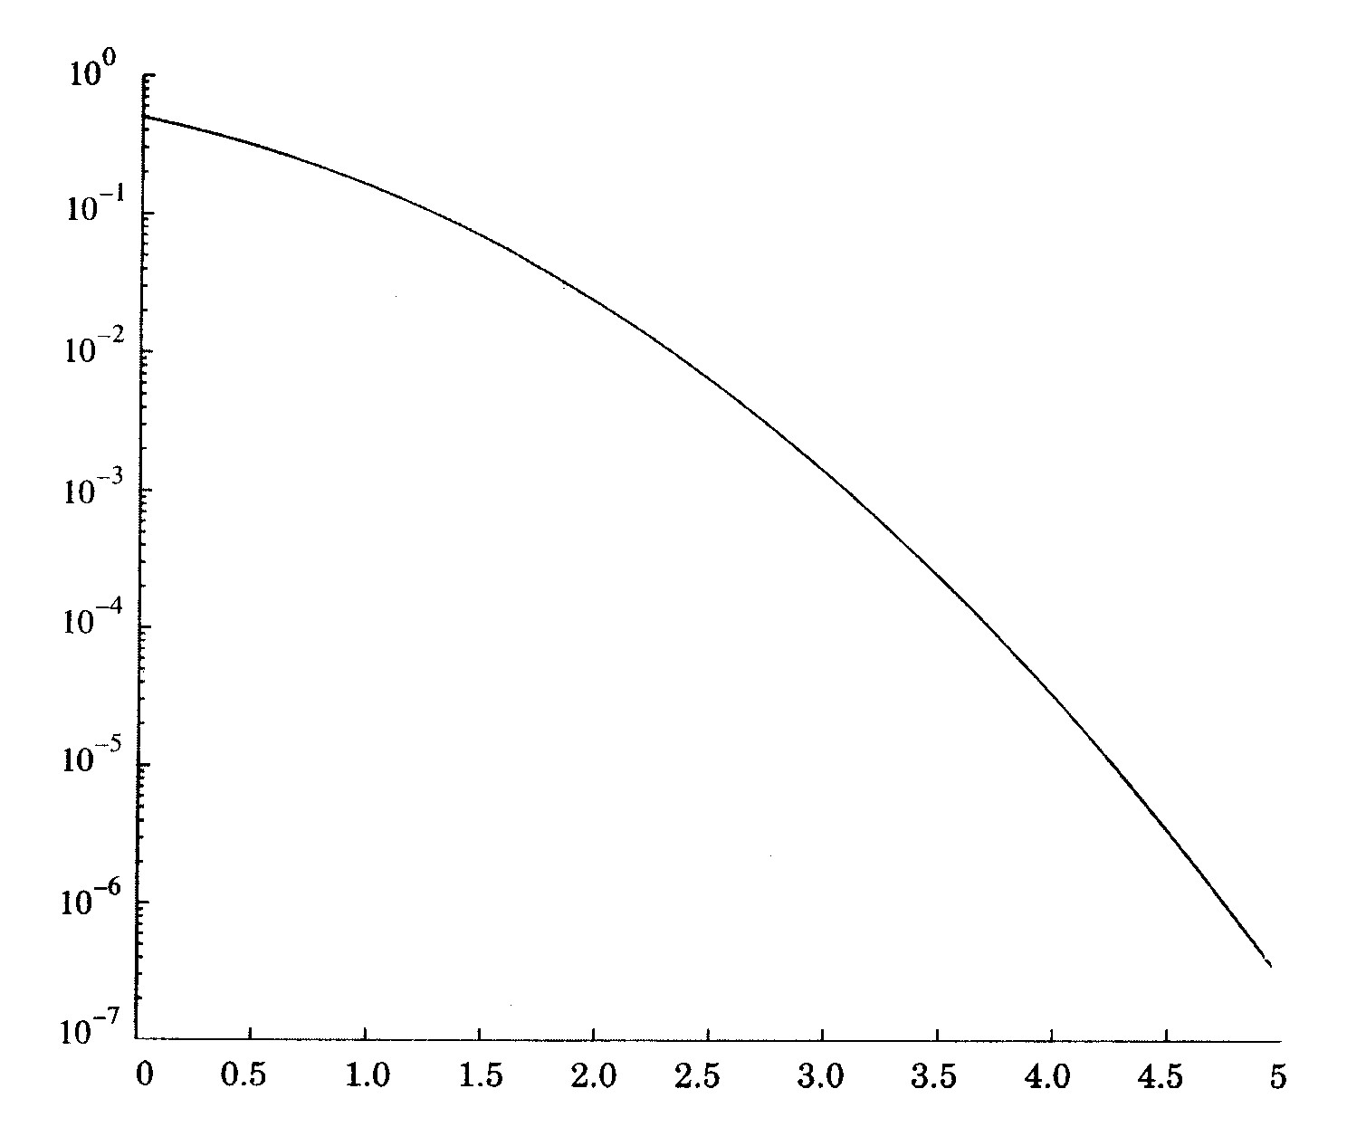
Figure F.2 Plot of the Q Function
1.(33 points) Find the cell radius for transmission from the mobile to the base station given the following:

power of the mobile = 600 mW
power allocated to the pilot channel = 15 mW
The interference must be at least 7 dB below the energy in each bit.
The noise figure of the cell = 5 dB
bandwidth = 2 MHz
chip rate = 1 MHz
data rate = 100 kHz
The cell is in use 40 % of the time.
Two high-gain directional antennas are used to transmit over the same
path as the cell. The transmitting antenna sends 0 dBm of power, and
-120 dBm is received by the other antenna 1 meter away.
Path loss exponent = 4, environment is typical outdoor environment (T =
290 degrees K)

Hint: Get started on the right foot:
Are you calculating the FORWARD or REVERSE link?

2.(33 points) How much other cell interference can you tolerate for the IS-95 system described below. INCLUDE units in W and dB in your answer.

IS-95 bandwidth = 1.23 MHz
IS-95 data rate = 9.6 kbps
Power of the mobile = 100 mW
Miscellaneous losses = 8 dB
Two dipole antennas are used to measure that the power transmitted over 1
m is 0 dBm. When the high gain base station and mobile antennas are used with the
same input power levels and same distance, 10 dBm is measured.
Path loss = 150 dB
Normal outdoor operating environment: depth of fade = 20 dB, T = 290 K
Noise figure of base station = 5 dB
System is used 40 of the time.
Number of mobile users is 25

3.(33 points) How many users can an IS95 cell support given the following conditions:

Probability that a call will be blocked = 2 %
Fading Margin = 20 dB
Path Loss Exponent = 4
Standard Deviation of the path loss = 4
Cell uses 2-way soft handoff
Information about the IS-95 Standard:
Data rate = 9.6 kbps
Minimum Eb/It = 7 dB
Chip Rate = 1.23 MHz
The system is active 40 % of the time
1/η = 10
Standard Deviation of Power Control = 3 dB

ECE 5325
Midterm #3

Name

SCORE:

Problem 1 of a possible 33 points

Problem 2 of a possible 33 points

Problem 3 of a possible 33 points

+1

Total of a possible 100 points

