|  |  |  |
| --- | --- | --- |
| 2240 |  |  |

Laboratory Project 4:  
Frequency Response and Filters

K. Durney and N. E. Cotter

Electrical and Computer Engineering Department

University of Utah

Salt Lake City, UT 84112

*Abstract*-You will build a filter that passes sinusoids of frequencies of about 0 Hz (DC) and 3 kHz and blocks frequencies of about 1 kHz and infinity (high frequency). The 1 kHz and 3 kHz frequencies are in the band of audio sounds we perceive, and the effect of the filter may be heard using earphones. The input to the filter in this lab is a triangular waveform which is equal to a summation of sinusoids of frequency 1 kHz, 3 kHz, 5 kHz, etc. The filter alters the shape of the triangular waveform by blocking the 1 kHz component.

1. Preparation

For Lab 4, which will last about two weeks, you will need the parts listed in Table I. You may purchase these parts from the stockroom next to the lab or purchase them elsewhere. The parts for listening to the sound are optional, (items 4-7).

TABLE I

Parts List for Lab 2

|  |  |  |
| --- | --- | --- |
| Item | Qnty | Description |
| 1 | 1 | 100 mH inductor |
| 2 | 1 | 10 kΩ resistor |
| 3 | 2 | Capacitors (values determined by calculations) |
| 4 | 1 | LF353 dual op-amp (optional) |
| 5 | 1 | 47 Ω resistor (optional) |
| 6 | 4 | 1 kΩ resistor (optional) |
| 7 | 1 | 47 kΩ resistor (optional) |

1. Learning Objectives

*1)* Learn how to use resonances to pass or block specific frequencies

*2)* Learn how to model impedance circuits using Matlab®

1. Introduction

In many engineering applications, it is important to be able to select signals of a given frequency, or signals in a given band of frequencies. For example, the signal picked up by a radio antenna consists of signals generated by thousands of transmitting stations (plus noise signals) at frequencies that literally cover the spectrum. A device in the radio receiver called a tuner selects one station by allowing signals at that station frequency (actually a very narrow band of frequencies) to pass, while rejecting signals at other frequencies. Another example is multiplexing in communications systems. In this method, a unique band of frequencies is allocated to each information channel, and many channels are sent over one transmission medium. At the receiving end, frequency selection techniques are used to separate the channels. Yet another example is the equalizer in an audio system. The equalizer is a series of frequency-selective circuits (or filters) that pass certain frequency bands such bass, midrange, or treble. The user adjusts the gain of the filters to emphasize or de-emphasize different frequencies in the music. Speakers in a stereo system will also have filters to separate bass signals (for the woofers), midrange signals (for the midrange speakers), and treble signals (for the tweeters). Frequency-selective circuits are also used in satellite communications, in television receivers, and in many other devices.

1. Analysis of Filter Circuit

In this project, you will design a frequency-selective circuit based on the circuit shown in Fig. 1. This circuit will strongly reject one frequency (1 kHz) and strongly pass another frequency (3 kHz), with intermediate response for other frequencies. This circuit is thus a combination of a band-pass and a band-reject filter.



Figure 1. Circuit for combined band-pass and band-reject filter (on left).

The transfer function, H(*j*), of the filter is given by the ratio of the phasor for the output, **V**o(*j*), to the phasor for the input, **V**i(*j*). This ratio is found by transforming the circuit to the frequency domain and finding the value of the voltage divider formed by the impedance to the right of **a**, **b** divided by the sum of *R*1 plus the impedance to the right of **a**, **b**.

To achieve the behavior of a band-reject filter centered at 1 kHz, the impedance of *L* and *C*2 is designed to be zero at 1 kHz. This turns out to be equivalent to setting the resonant frequency of *L* and *C*2 to 1 kHz. At resonance, the impedances of *L* and *C*2 are equal but opposite—one is positive imaginary and the other is negative imaginary.

To achieve the behavior of a band-pass filter that passes 3 kHz, the parallel combination of *C*1 and *L* plus *C*2 must look like an open circuit at 3 kHz. How this can be achieved may be understood by first considering a simpler situation. If *C*1 were in parallel with just *L*, then the parallel impedance would look like an open circuit (i.e., infinity ohms) at the resonant frequency of *C*1 and *L*. At the resonant frequency the sum of the impedances is zero, and the sum appears in the denominator of the parallel impedance, which equals the product of impedances over the sum of impedances. The divide by zero means the parallel impedance appears to be infinite or an open circuit. It is though the parallel *C*1 and *L* would seem to disappear!

The inclusion of *C*2 alters the situation slightly by lowering the apparent impedance of *L* plus *C*2. (The impedance of *C*2 is negative imaginary, whereas the impedance of *L* is positive imaginary.) Nevertheless, the combination of *L* and *C*2 looks like the impedance of an inductor (positive imaginary) above the resonant frequency of *L* plus *C*2, which is 1 kHz by design. Thus, we can find a value for *C*1 that will yield an impedance that is the negative of the impedance of *L* and *C*2 at 3 kHz.

1. Design of Filter Circuit

The design objective is a circuit that will reject a 1 kHz sinusoid and pass a 3 kHz sinusoid. Based on the above discussion, derive an equation that the value of *C*2 must satisfy in terms of *L* and  so that the circuit will reject frequency . Then derive an equation that the value of *C*1 must satisfy in terms of *L*, *C*2, and  so that the circuit will pass frequency 3.

Assuming *L* = 100 mH, calculate the values of *C*1 and *C*2. Procure *L*, *C*1, and *C*2 from the stockroom or another source. If necessary, use several capacitors in parallel to achieve approximately the desired value of *C*1 and *C*2.

1. Characterization of Components

A. Resistor

Procure a 10 kΩ resistor for *R*1. Use an ohmmeter to measure its actual value.

B. Inductor

The inductor you are using has a series resistance, *R*s, and a parasitic capacitance, *C*s. Fig. 2 shows a model of the inductor that includes these non-ideal characteristics. In order to make accurate predictions of the filter's response to different frequencies, we must include *R*s and *C*s.



Figure 2. Model of inductor (shown at far right).

To characterize your inductor, first measure the inductance, *L*, of your inductor using a suitable meter. If necessary, check out such a meter from the equipment window.

To measure *R*s, use a conventional ohmmeter to measure the DC resistance of the wire in the inductor, or use the value given by an *RLC* meter. Note, however, that the *RLC* meter may measure the value of *R*s at a particular frequency that may be higher than those we use in the filter circuit. Consequently, the value of *R*s at frequencies of interest may not be measurable by the meter.

To measure *C*s use one of the following two methods, as instructed by your T.A.:

*1)* Use an *RLC* meter. This is the simplest approach, but such meters are sometimes sensitive and give inconsistent readings.

*2)* Use the resonant frequency of *L* to determine *C*s. The idea here is that the model of the *L* in Fig. 2 is a resonant circuit. Ignoring *R*s for the moment, this resonant circuit will look like an open circuit at the resonant frequency of *L* and *C*s. It follows that one way to measure *C*s is to use a sinusoidal function generator to drive a large resistor (much larger than *R*s) connected in series with the inductor and adjust the frequency of the generator until parallel resonance of *L* and *C*s occurs. That is, adjust the frequency of the generator until the voltage across the resistor reaches a minimum. *C*s may then be calculated using the measured values of the resonant frequency and the inductance (assuming Rs can be neglected). A better estimate of *C*s may be obtained by analyzing the actual effect of *R*s.

C. Capacitors

Measure the capacitance of your capacitors using a suitable meter. If necessary, check out a meter from the equipment window. If you use more than one capacitor for *C*1 and *C*2, you may sum the values of individual capacitances.

1. Plots of Filter Response

A. Motivation

With a sufficiently accurate model, we can predict the output of the filter circuit. In this part of the lab, you will write a Matlab® program to calculate the filter output. You will compare the predicted output with the measured output later on.

B. Transfer Function

As the first step in calculating the output of the filter, write a function that calculates the transfer function, *H*(*j*) = **V**o/**V**i, of the circuit in Fig. 1 as a function of . The syntax of the function call should be as follows:

H_omega = Hjw(omega);

The returned value will be a complex number in rectangular form, *a* + *jb*. Code component values for the circuit into the Hjw function, but define them at the beginning of the function so they may be easily changed. In writing the code for calculating the phasor **V**o, you will need an expression for the complex impedance *z*ab. Instead of reducing the expression for *z*ab algebraically, leave it to Matlab® to calculate it from 1/(*j* *C*1), etc. Note that Matlab® can calculate parallel and series impedances sequentially, alleviating the need for a derivation of *z*ab on paper. Note also that the transfer function may be calculated as the output phasor **V**o when the input phasor equals unity.

In certain situations, a divide by zero might occur in the calculations. Add checks for divide by zero to prevent the code from failing.

C. Frequency Response

As the second step in calculating the output of the filter, write a script file that calculates the filter transfer function for frequencies from  = 0 r/s to  = 2·6 kr/s. Save the values in an array for plotting.

D. Plot of Frequency Response

Create superimposed plots of the magnitude of the transfer function versus frequency for the filter in Fig. 1 under two conditions:

*1)* With ideal component values.

*2)* With actual component values (including *R*s and *C*s).

1. Construction and Measurement of Filter Circuit

Construct the filter circuit in Fig. 1 on a breadboard and connect a function generator to the input. (This is *v*g(*t*) in Fig. 1.) To facilitate debugging, start by connecting *R*1 and *C*1 and setting the input signal to a 1V high square wave. For a square wave input, *v*o(*t*) will show a characteristic exponential *RC* charge and discharge curve. Having verified this waveform, connect *L* and *C*2.

With the complete circuit, switch the circuit input waveform to a sinusoid and measure the frequency response of the circuit. (Use the menu buttons on the function generator to be sure the function generator is set to high output-impedance mode. Otherwise, the generator output voltage will be off by a factor of two.) Using a 1V amplitude input sinusoid, measure the amplitude of the filter output signal for frequencies between *f* = 0 Hz to *f* = 6 kHz. Select points that will adequately reveal the shape of the frequency response curve. Note that frequencies around 1 kHz and 3 kHz are of particular interest.

Use Matlab® to plot your results. Superimpose the results on your dual plot of the predicted frequency response from the previous section. Be careful to convert from units of Hertz to units of radians per second. Comment in your lab notebook on the accuracy of the predicted values.

1. Effect of Filter on Triangle Wave

To illustrate the effect of the filter on a non-sinusoidal waveform, set the input signal to be a 1 kHz triangular waveform. According to Fourier theory, the triangular waveform at 1 kHz is equal to a summation of sinusoids of frequencies 1 kHz, 3 kHz, 5 kHz, etc. The formula for a triangular waveform is as follows:

 (1)

According to the principle of superposition, the output of the filter will be the summation of the response of the filter to each of the sinusoids in (1). The output amplitude will be the input amplitude times the frequency response for that frequency. Since our filter is designed to eliminate the 1 kHz signal and pass the 3 kHz signal, we would expect that the output signal would look more like the 3 kHz signal. (Note that the 5 kHz signal is small going into the filter and, as the filter frequency response curve shows, the response of the filter makes the small signal even smaller. If possible capture the filter input and output waveforms using an oscilloscope and plot them in Matlab®. Otherwise, sketch the input and output waveform of the filter circuit as shown on the oscilloscope. Comment on whether it appears that the 1 kHz signal is eliminated.

1. Effect of Filter on Audio Signals (Optional)

If you are interested in hearing how the filter circuit affects an audio waveform, you may build the circuit in Fig. 3. (Substitute the filter circuit in Fig. 1 for the RLC bandpasscircuit shown in the middle section of Fig. 3.) You may use the output from your mp3 player as the audio input with the output out going to your earphones. Because we are used to hearing distorted sounds, the music may not sound very different to you when it goes through the filter. To exaggerate the effect, try using a 1 kHz triangular waveform as the input. (Use a small-amplitude signal and slowly ramp it up until the output is audible in your earphones.) After listening to the filtered sound, bypass *R*1 to hear the unfiltered sound. The sound should be much lower, since it will contain a stronger 1 kHz component.

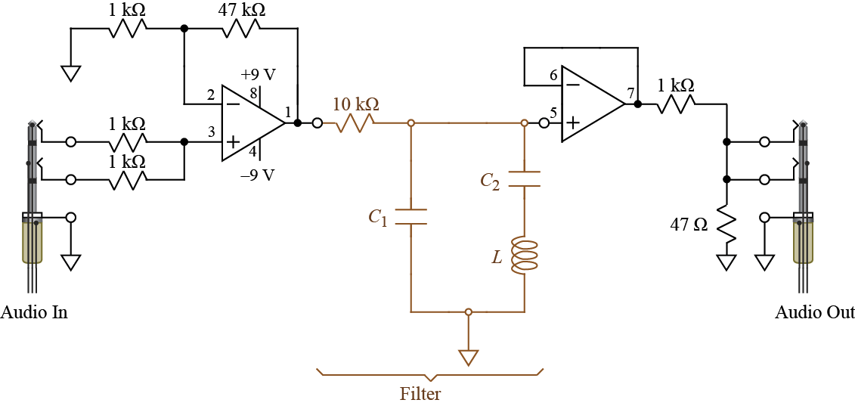

Figure 3. Circuit for audio signals

Notebook and Report

Turn in a copy of your laboratory notebook pages and a separate formal report. Refer to the grading information on the course website for the section numbering to use while writing the formal report. Use the IEEE format for typesetting. Information about the IEEE format, including a template file, is available on the course website. Additional information about writing the report and keeping a notebook is listed in the *Course Procedure* on the course website. Note that Matlab® plots, if they are listed in the contents of the report, must appear both in the laboratory notebook *and* the formal report.