Lab 2: Real-World Applications of Resistive Networks

Possible Points: 67

Lab Equipment List:

- Breadboard and wires
- Resistors from your kit (2x 1 kΩ, 2kΩ, Photoresistor, Potentiometer(you’ll see the picture below)); the resistors in your kit are 1/4 W resistors, so do not have your resistors dissipate more than this amount of power or you may damage your resistors.
- Additional Resistors of your choice
- Triple Output DC Power Supply
- Digital Multimeter (DMM)
- Wires with connectors on one end and alligator clips on the other
- In addition, checking out a portable multimeter from the stockroom can be useful.

Partnering:

- Everyone must create their own lab report (fill out this document).
- Groups are allowed to be maximum of 2 except in a class of odd numbers; in that case one group will be allowed to be 3. A group may use the same measurement equipment.
- Discussions are encouraged, and you are also encouraged to answer each other’s questions!
- Seek out the TA if you get stuck or need help.

Lab Procedures:

Welcome to Lab 2! This lab is designed to help you see how even simple circuits comprised only of resistive elements are useful in the real world. For example, resistor networks can be used to create resistive sensors, which convert a real world stimulus into specific resistance values. There are a variety of different sensors that work this way:

- Potentiometers: Also known as pots or variable resistors, these resistors have a knob that allows a variable amount of resistance to be selected as shown in Fig. 1 (i.e. they have three terminals instead of two as for regular resistors). The variable resistance may be selected manually by adjusting the knob of the potentiometer.

What do you think would happen if we connected a moveable object to the knob of a potentiometer? And how might this be useful?

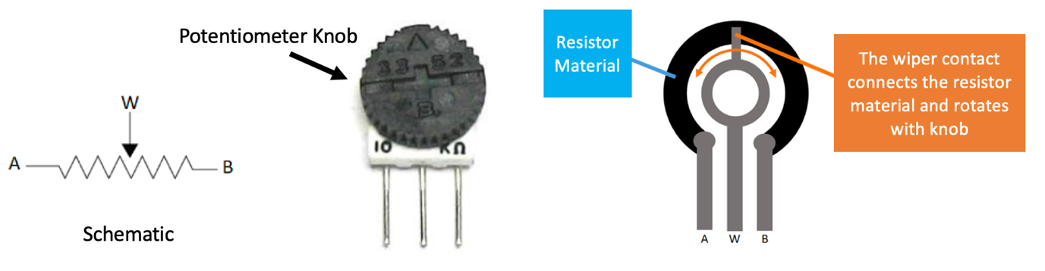
Fig. 1 A schematic (left side), image (center), and diagram (right side) of a potentiometer (courtesy of Seattle University).

Potentiometers may be used to provide position information when a moveable object is connected directly to the rotation shaft or slider of the potentiometer as seen in Fig. 2. Used in this manner, a potentiometer can measure angles up to ~265°. Also, in this way, a potentiometer forms a voltage divider.
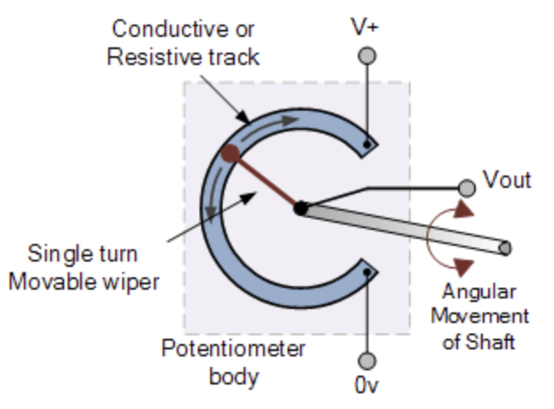
Fig. 2. A potentiometer arranged to provide position information (courtesy of electronics-tutorials.ws)

- Thermistors: Thermistors change their resistance as the temperature changes. A thermistor generally has a base resistance (at 25° C) and then the resistance changes linearly with any change in temperature.
- Photoresistors: Photoresistors change their resistance based on the amount of light that is incident on a specific surface. A photoresistor generally has a relatively low resistance (like 20 kΩ) when illuminated and a very high resistance (like 10 MΩ) when not illuminated.
- Strain Gauges: Strain gauges are comprised of a long wire doubled back on itself as shown in Fig. 3. These are used to measure the strain (and therefore the forces) on an object. We can see this by considering the resistance of a long, straight rectangular conductor, which is calculating using R=ρ(l/A) (l is the wire’s length, A is the cross-sectional area, and ρ is the conductivity). When the sensor is compressed, the length of the conductor decreases and the area of the conductor increases, which leads to less resistance. Conversely, when the sensor is experiencing tension, the resistance increases.
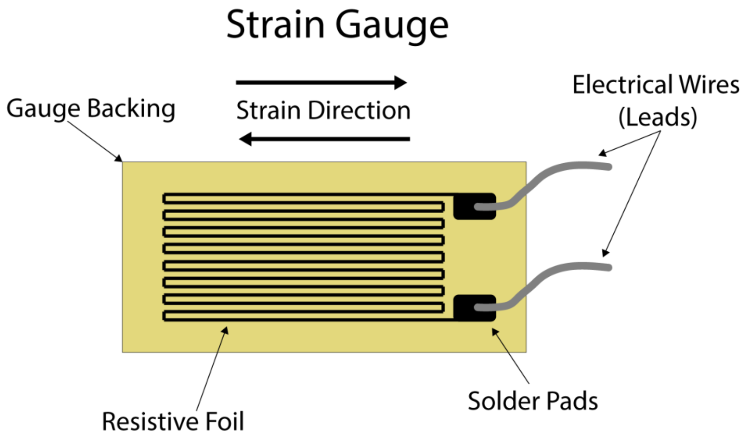
Fig. 3 Diagram of a strain gauge comprised of a long wire folded back upon itself (courtesy of Michigan Scientific Corporation).

- Touch Sensors: A resistive touch sensor is one of the simplest forms of a touch sensor (unlike the capacitive versions found in phones, which can detect multiple finger movements at once and have faster response times). Resistive touch sensors involve two sets of conductors just barely separated by a spacer as shown in Fig. 4. By applying a small amount of pressure to the top conductor, the circuit is completed and a change in resistance is registered (so it behaves just like a switch).
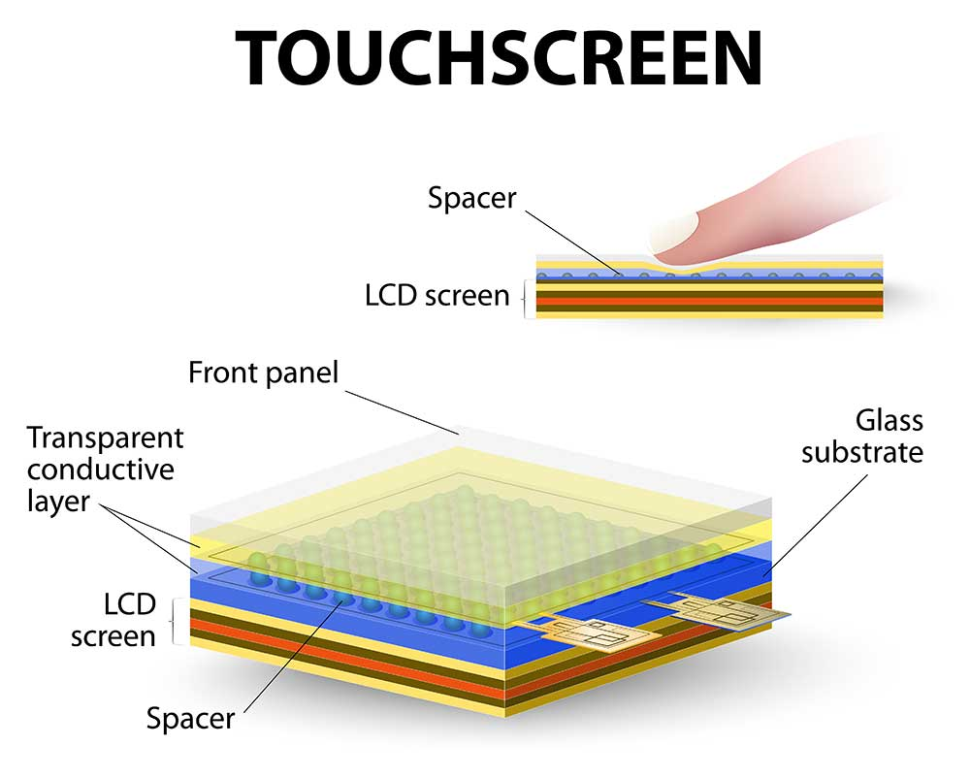
Fig. 4 A simple touchscreen with resistive sensors (courtesy of WELLPCB).

A couple things to note about resistive sensors:
- All of the above resistive sensors measure a change in resistance rather than specific resistive values (however, several resistive sensors may be combined in a specific way or combined with other elements to determine an unknown resistance as we will see in Part 4 of this lab).
- Many of the resistive sensors are not linear, meaning that using a voltage directly from a voltage divider may lead to skewed values. In many general solutions, this is handled by the software on a microcontroller, or it may also be handled by electronics directly.

Part 1: Photoresistors.(7pts)

- Take the photoresistor (a.k.a. light-dependent resistor, or LDR) out of your kit.
(As necessary, use a web search to figure out what these look like.)

- Measure its resistance at various light levels.

- Over what range of resistance values (in ohms) do you think we could consider the output to be “dark” vs. “light”? (5pts)

Dark < R < Light < R <

- Give an example of an application where you think this might be useful. (2pts)

<fill in >

Part 2: A Potentiometer as a Variable Resistor (10pts)

- Take the potentiometer (pot) out of your kit.

- Measure the resistance of the potentiometer between the outer two pins while you turn its dial. Is this what you would expect? (5pts)

<fill in >

- Measure the resistance between the middle pin and one outside pin and then the middle pin and the other outside pin as you turn the dial. What are the relationships between the resistances seen on the pins? (3pts)

<fill in >

- Give an example of an application where the resistance between the middle pin and an exterior pin might be useful. (2pts)

<fill in >

Part 3: A Potentiometer as a Voltage Divider (20pts)

- As explained earlier, potentiometers may be used to create miniature voltage dividers. Connect your potentiometer as shown in Fig. 5, with the outside pins connected to a 10 V source and the middle pin connected to a voltmeter. Turn the dial of the potentiometer and notice how the voltage changes.

Fig. 5 A voltage divider implemented with a potentiometer.

- How does this circuit relate to the voltage divider equation learned in class? (2pts)

<fill in >

- How does the voltage change (as in, is it linear)? Why? (2pts)

<fill in >

- For some applications, we may not want the output of the potentiometer to cover the full range of possible input voltages (from ground to the supply voltage). Instead, we may want the output voltages to extend over a narrower range of voltages. One way to solve this problem is to add a resistor in series with the potentiometer as shown in Fig. 6. In this example, there is a 10 kΩ potentiometer (its resistance can vary from 0 to 10 kΩ). How does adding a resistor solve the input range problem? (5pts)
Note:this is a theoretical question, you don't have the parts to build this circuit.

<fill in >

Fig. 6 A circuit with a resistor before the potentiometer.

- How would the voltage vary between the lower and middle terminals of the potentiometer with this arrangement? Provide a voltage range as the wiper of the potentiometer is varied from is to 10 kΩ. (2pts)

<fill in >

- Another way of solving this problem is to add a resistor both before and after the potentiometer, as shown in the circuit of Fig. 7. How would the voltage vary between the lower and middle terminals of the potentiometer with this arrangement? Provide a voltage range as the wiper of the potentiometer is varied from is to 10 kΩ. (2pts)

<fill in >

Fig. 7 A circuit with a resistor both before and after a potentiometer.

- Design (draw a circuit diagram for) a voltage selector that selects 1 - 5 V using a 10 kΩ potentiometer and a 6 V supply. (HINT: It's easy to find the current through the potentiometer, and then find the other resistors from that.). (5pts)

<add your design here>

- Give an example of an application where you think this might be useful (being able to select a specific range of voltages from a broader range of voltages). (2pts)

<fill in >

Part 4: Test a Wheatstone Bridge Car Seat Sensor (24pts)
In this part of the lab, we will build and test a car seat sensor that is comprised of a Wheatstone Bridge having one strain gauge as shown in Fig. 7. This sensor will be placed at the bottom (or inside) of the car seat as shown in Fig. 8. When someone sits in the seat as shown in Fig. 9, the strain gauge will experience strain from the weight of the person. We want to determine the amount of strain that the strain gauge experiences in order to determine whether an adult or child is sitting in the seat. This will make it possible for a microcontroller to make the airbags deploy in a safe manner depending on the size of the person sitting in the seat.

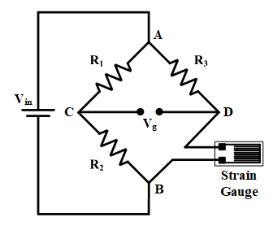
Fig. 7 A Wheatstone bridge with one strain gauge to measure one unknown resistance developed by the strain gauge (courtesy of hardwarebee.com).
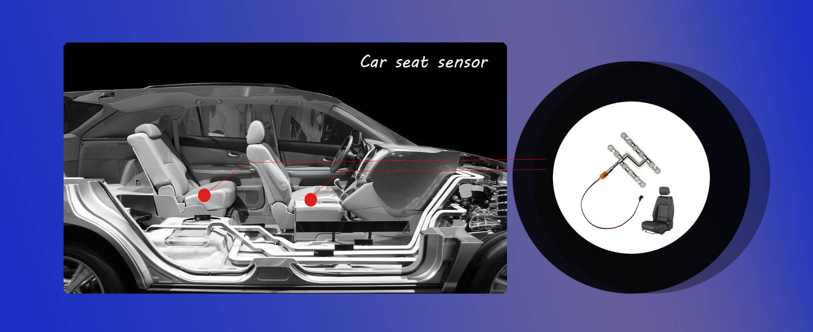
Fig. 8 Each car seat in a car has a sensor to determine whether someone is sitting in the seat and the weight of that person, i.e. is it an adult or a child, etc. (courtesy of fsrtek.com).
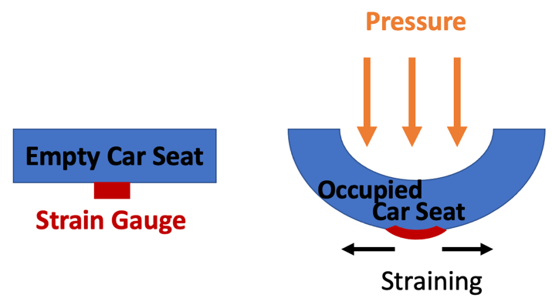
Fig. 9 A diagram of a strain gauge under a car seat (which could also be built into the car seat). On the left, there is no one sitting in the seat, so there is no strain on the strain gauge. On the right, the seat is occupied, which places pressure on the strain gauge.

- As described in the introduction, the resistance of the long wire segments in the strain gauge is R=ρ(l/A) (l is the wire’s length, A is the cross-sectional area, and ρ is the conductivity). If someone sits in the car seat, would the resistance of the strain gauge increase or decrease? (5pts)

<fill in >

- Although we won’t be directly using a strain gauge in this lab, we can imitate the impact of the force on the strain gauge by using specific resister values. Build the Wheatstone Bridge shown in Fig. 10 on your breadboard. Use 1 kΩ for R₁ and R₂, and 2 kΩ for R₃ with a 10 V voltage supply. Then choose a resistor from your kit for R₄ that might represent an adult sitting in the car seat. Note: Strain gauge resistances only change by small percentages.

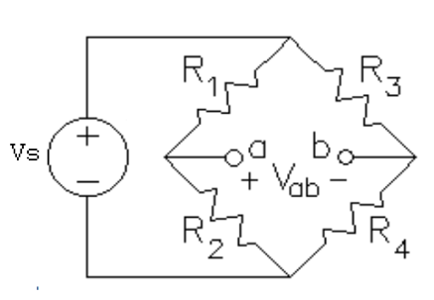
Fig. 10 The circuit diagram of the Wheatstone Bridge circuit we will build in this lab, with R₁, R₂, and R₃ representing known resistance values and R₄ an unknown resistance (developed from a strain gauge as shown in Fig. 7).

- Fill in the “Choice of R₄ Representing an Adult Sitting in the Car Seat” row of Table 1 R₄.

- Replace R₄ with a resistor of a different value that might represent a child sitting in the seat. Measure V_{ab} again and then fill out the “Choice of R₄ Representing a Child Sitting in the Car Seat” row of Table 1.
 | Resistor Value from  the color code  (1pts/unit) | Measured Vab  (2pts/unit) | Calculated Vab  (3pts/unit)
Choice of R₄ Representing
an Adult Sitting in the Car Seat
Choice of R₄ Representing
a Child Sitting in the Car Seat
Table 1 Comparison of R₄ values in the Wheatstone bridge. (12pts/total)

- Compare your values in Table 1. How well do they agree? Does the circuit work as expected? (2pts)

<fill in >

- What sources of error are present? (2pts)

<fill in >

- Based on your equation and your experience, does this circuit provide a linear V_{ab} voltage for varying resistances? If it is not linear, in what ranges might this circuit be more accurate? Less accurate? (3pts)

<fill in >

Part 5: Use the Wheatstone Bridge to Compare a Signal (6pts)
One of the many applications of a Wheatstone bridge is to generate a digital (on or off) signal from a resistive sensor. This circuit, which is shown in Fig. 11, uses an op-amp (which we will cover later this semester) to compare the photoresistor voltage (created via a voltage divider with R₃) to a known voltage that is determined by R₁ and R₂ (via a voltage divider). The circuit will generate a digital “on” (i.e. turn the LED on) when V_{ab} is positive, and a digital “off” (i.e. turn the LED off) when V_{ab} is negative. The TA will demonstrate this by showing a prebuilt circuit to you in small groups, the circuit for which is shown below. If you would like to see a video on how this circuit was built, you can view it here: https://www.youtube.com/watch?v=iGJtnrnMQQU
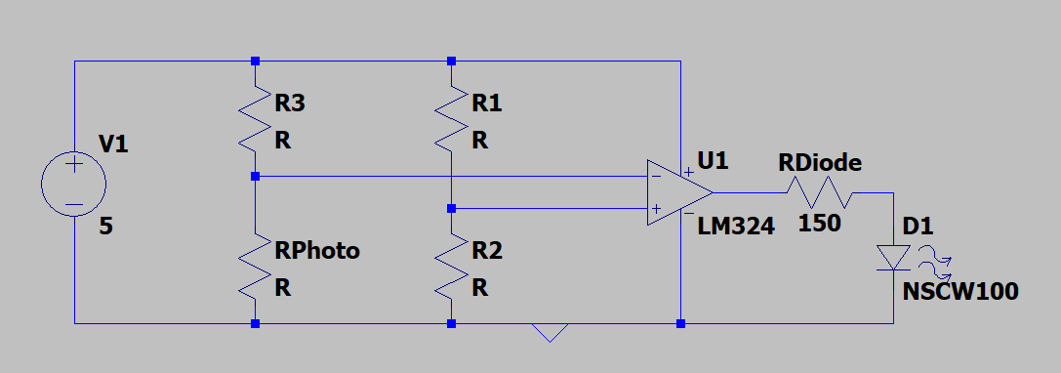
Fig. 11 A Wheatstone bridge with a photoresistor in place of R₄, along with an op-amp and a diode (RDiode is the internal resistance of the diode).

- We won’t be building the complete circuit shown in Fig. 11. However, let’s see the impact of having a photoresistor with a varying resistive value that depends on the light level that is incident on it. Replace R₄ in the Wheatstone bridge with your photoresistor.

- Using your results from Part 1 of this lab, choose values for R₁, R₂, and R₃ such that the V_{ab} is positive when it is “light” and negative when it is “dark” (You may find the resistance of where this change is useful for your design). Make sure your design uses resistor values that can be found in your kit. Hints: make R₁ = R₂ and R₃ comparable to the mid-light value of the photoresistor.

- Test your circuit with a voltmeter to test whether it is working as intended, and measure the voltage to ground for both voltage dividers in both the on and off configuration.

- How does this circuit use the bridge concept to get usable data from a resistive sensor? (2pts)

<fill in >

- How did you design the circuit and what values did you use for the resistors? (2pts)

<fill in >

- Give an example of an application where you think this might be useful. (2pts)

<fill in >

- Before you tear down your last circuit and leave the lab today, make sure to have your Lab TA check off your lab by showing what you accomplished in your lab report.

- Turn in this completed report to Canvas by the due date posted on Canvas.

- Put all of the lab supplies away, including your own lab kit and anything you may have checked out!

