WLAN FSK Receiver Design
ECE 6180 Laboratory Project

By Cynthia Furse and You Chung Chung

Department of Electrical and Computer Engineering, Utah State University

Introduction
Wireless Local Area Networks (WLAN) are commonly used to connect devices such as computers and printers or other peripherals. In this lab, you will build a receiver for a Frequency Shift Keyed (FSK) WLAN.
Figure 1 shows a block diagram of the FSK transmitter/receiver system. The concept of this FSK system operation is that a digital “0” is transmitted at 2.4 GHz, and a digital “1” is transmitted at 2.6 GHz. Thus, either a 2.4 GHz or 2.6 GHz signal is transmitted from the first computer to your receiver board. The job of the receiver is to determine which frequency has been received, and convert it back into a digital “0” or “1”. The receiver antenna must be well-matched to both the 2.4 and 2.6 GHz signals. The signal from the antenna is then amplified and split into two identical copies using a 3 dB power divider. The narrow-band filters at 2.4 and 2.6 GHz pass or reject depending on if the signal was a “0” or “1”. Only one filter should pass at a time. The signal envelopes are extracted using diode detectors fabricated from zero-bias schottky diodes, and the resulting waveforms are run into a voltage comparator whose output voltages are set to those of TTL logic. This output signal can then be received by the UART of a personal computer and interpreted using acquisition software. Figure 2 shows the physical layout of the receiver system.

Lab Procedure
Each block of the receiver system is done as a separate lab experiment, and most blocks are directly associated with lecture and related homework topics in the course. It is critical that you keep up with assignments in class in order to do your lab effectively. In general, you will design a circuit and submit it to be milled on week. The next week, you will measure this circuit and also design/submit the second circuit, and so on. Please do not get behind! You may have to redo some of your circuits, which you will have time to do if you keep up, but not if you leave it until the very end.
You will work in groups of 3 in the lab, so find compatible partners with schedules that match yours. We have very limited lab equipment for this lab, because it is prohibitively expensive. Consequently, we will be doing the lab sequentially. Sign up sheets will be passed around prior to the first two labs to let you sign up for times that the TA is available. During these labs, you will learn to use all of the equipment that is needed. Later labs, you will sign up for any time throughout the week to complete your measurements, as you will probably require little or no help from the TA.
Lab books are required. Each student should do his or her own designs, and the group should then get together and compare designs to determine which is best for milling. Your book should include your OWN design as well as the design chosen by your team. All details for the derivation and analysis should be included, as well as final dimensions, a Xerox of the part, and a comparison of measured and predicted data.
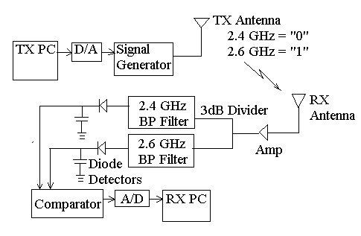
Figure 1 – Wireless Local Area Network Block Diagram.
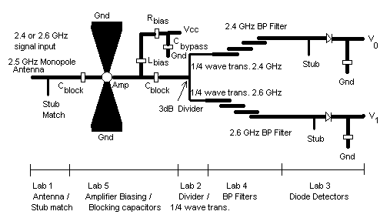
C
C

Figure 2 – Wireless Local Area Network receiver layout.
Lab 1: Monopole antenna and matching stub(s)
Lab 5: Amplifier biasing network and DC blocking capacitors
Lab 2: 3dB divider and quarter-wave transformers
Lab 4: Band pass filters
Lab 3: Diode detectors and matching stubs
Lab 6: System integration and test

