ECE 3300 Lab #1: Dielectric Properties
Located in MEB 2275
Objectives:
1. Understand Dielectric Properties ε, and σ.

2. Be able to convert ε, and σ to ε = ε’ – j x ε’’

3. Learn to make tissue simulate, and understand its electrical properties. Be able to compute propagation constant, wavelength, and attenuation in material.

Prelab: Read through this lab handout, read section 1.2 in the text about electric fields, and the following article, available on the lab website.

1.G. Hartsgrove, A. Kraszewski, and A. Surowiec: Simulated Biological Materials for Electromagnetic Radiation Absorption Studies. Bioelectromagnetics 8:29-36 (1987)

Plot the ε and σ values in Table 2 for the muscle and brain. Which tissues needs more salt to simulate them? Which need more sugar?

Compute the values of 2/3 muscle at 400 MHz. The values of 2/3 muscle can be computed as
ε_{r} = 2/3 x ε_{muscle}
σ = 2/3 x σ_{muscle}

Optional Reading
2. The dielectric properties of biological tissues.( on class websight)
3. Application Note 1217: The basics of measuring dielectric properties of materials.
(on class websight)

*Note that the handout The dielectric properties of biological tissues, gives value in mSiemens/cm, and that it needs to be converted to Siemens/meter.

For more information on tissue properties go to:
niremf.iroe.fi.cnr.it/tissprop/ ( on class websight)
www.brooks.af.mil/AFRL/HED/hedr/reports/dielectric/Report/Report.html (on class websight)

For more information of the dielectric probe:
www.agilent.com search for 85070 (on class websight)

*Note that the probe gives relative values to ε and μ. ε₀ = 8.854e-12 F/m, and μ₀ = 4 x pi x 1e-7 H/m. In other words, μ = μ_{r} x μ₀ and ε = ε_{r} x ε₀. For this class assume μ = μ₀.

For more dielectric values go to
www.asiinstr.com/dc1.html

ε_{r} for oil is 2.8-3.4
ε_{r} for sugar is 3.0
ε_{r} for salt is 6.1

Lab Equipment Needed
HP85070M Dielectric Probe Measurement System
Network Analyzer
Computer connected to Network Analyzer with 85070 software running

Materials Needed

Paper Towels
Measuring Cups/Spoons
De-ionized Water
Cooking Oil
Salt
Sugar

Prelab Discussion: Review physics of how dielectric materials interact with electric fields. Discuss how H₂O, salt, sugar, etc., impact ε, and σ.

Discuss and understand loss tangent, skin depth, conductivity, and other ways to measure dielectric values. Additional information is found in the application note 1217-1 and in your textbook.

Procedure
Caution; be very careful with these materials so that they do not get on any lab equipment. Microwave equipment is VERY EXPENSIVE. If you do spill any material, quickly clean it up so that it doesn’t spread.
Microwave equipment is extremely sensitive to static discharge. Always wear the static dissipative wrist straps when touching the probe or the network analyzer ports.

1. Divide into groups of 3-4. The TA will demonstrate the calibration of the dielectric probe. Record calibration procedure in your lab notebook.

2. Measure the dielectric properties of de-ionized water, and oil. Record values at 400 MHz.

3. Pick a tissue from the dielectric properties handout to simulate.
Compute the complex permittivity of the solution needed to simulate the tissue at 400 MHz.

Remember
$$ε_{r} ε_{0}\text{ =}ε\text{= }ε'−jε\text{''} = ε_{r}ε_{0}−\frac{jσ}{ω}= ε_{r}' ε_{0} − {jε}_{r}\text{''} ε_{0}$$
σ= conductivity in Siemens/meter
ω= frequency in radians/second

*Note that the handout The dielectric properties of biological tissues, gives value in mSiemens/cm, and that it needs to be converted to Siemens/meter.

*Note that the probe gives relative values to ε and μ. ε₀ = 8.854e-12 F/m, and μ₀ = 4 x pi x 1e-7 H/m. In other words, μ = μ_{r} x μ₀ and ε = ε_{r} x ε₀. For this class assume μ = μ₀.

4. Estimate amount of salt and sugar needed to simulate tissue of choice in 50 mL of water. Carefully record selected amounts of sugar, and salt in mixture.

Note: Adding salt increases conductivity and reduces dielectric constant. Adding sugar reduces the dielectric constant and somehow binds with the salt and reduces its conductivity. Good results were obtained for brain using 50 mL of water 1.25 tsp of salt and 1/8 cup + 1 tsp sugar.

5. Mix salt and sugar with water to achieve desired results. Stir mixture thoroughly. The salt and sugar must be fully dissolved.

6. Measure mixture with probe.

7. Adjust the mixture, recording changes to mixture composition.

8. Measure again and record final mixture. Record dielectric properties of final mixture at 400 and 440 MHz, as we will be using 440 MHz values for future labs. Write results in lab book.

9. PLOT the quantity of sugar and salt versus the relative permittivity and conductivity. You may use results from your group as well as others.

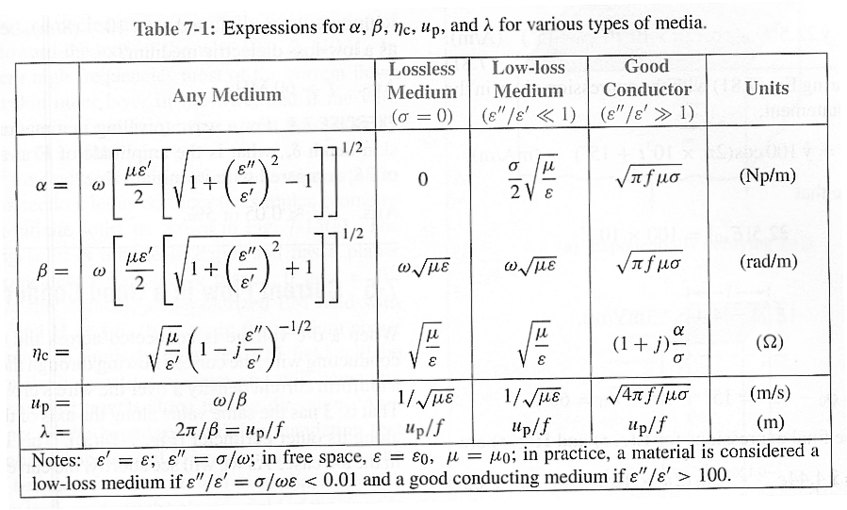
From Ulaby, “Fundamentals of Applied Electromagnetics” Second Edition

Questions?
Compute velocity of propagation, alpha, beta and wavelength in air, Teflon, sea water, and your tissue simulant mixture at 440 MHz. Constants can be found in Appendix B of your text. Assume Teflon and air have zero conductivity.

How well did your mixture compare to the measurements in the reading material?

Observations and Conclusions?
Discuss your results. Approximately how far into tissue do you expect a 440 MHz wave to propagate? (see the definition of “skin depth” to answer this question). How do sugar and salt affect the electrical properties of material? Are the electrical properties (permittivity and conductivity) linearly proportional, second order, etc. in relation to the amount of sugar and salt.

