To insert an equation:
- Insert->Object
- Select Microsoft Equation 3.0 from the list and hit OK
- You will get a floating box with an equation editor toolbar that only appears while you are editing the equation, as shown in Figure 1.

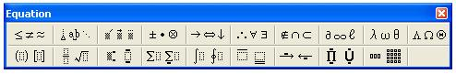

Figure 1: Equation Editor Toolbar

- You can then use the keyboard to enter in variables and numbers and the toolbar to enter in special characters and formatting as shown in Equation 1.

$A=\sum_{i=1}^{n}{x_{i}∗β}$ (1)

- Use the right and left arrows to select pieces of the equation to format, as shown in Figure 2.

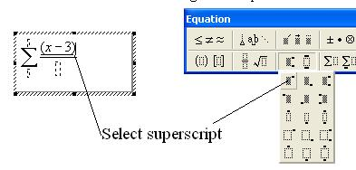
Figure 2: Equation Editor Sample of Formatting

- As you enter in formatting, you can use the mouse to click on different dotted placeholders to fill in information, as shown in Figure 3.
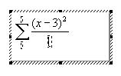
Figure 3: Equation Editor Sample of Placeholders

- Good luck! You’ll get the hang of it as you experiment with different equations!

