How to Convert AutoCAD Layout (.dxf) File into LPKF Milling File
(Before Using Board Master Manual)

Peijung Tsai
You Chung Chung

University of Utah
Electrical and Computer Engineering Dept.

April 20, 2004
Table of Contents

Start to Use CircuitCAM
1. Open the program 3
2. Import .DXF file 3
3. Define the contour 4
4. Define insulate layer 5
5. Insulate all layers 7
6. Export the data into CircuitPlotter 7

How to Convert AutoCAD Layout (.dxf) File into LPKF Milling File
(Before Using Board Master Manual)

Program/File needed:
- AutoCAD layout file in .dxf format
- CircuitCAM 3.2

Start to use CircuitCAM
- Go to “Start/Programs/LPKF32/CircuitCAM3.2” and CircuitCAM program will pop out

- Go to “File/Import/Choose file name” or click on the file import icon to choose the file to be imported
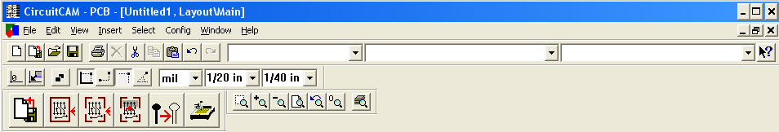

- File-Type: DXF
- Layer: Depends on your need, but usually set it as “TopLayer”
- Aperture List: “DXF Inch Unit” and “DXF mm Unit” available. Choose the one you used in your AutoCAD file.
- Unit: the scale maybe off in the order of 10, change it to 10, 100 or 1000 until you have the correct size in “Size x,y” section. Or you can compare the imported size from “Size x,y” and find the ratio by comparing it to your actual design size.
- Click “Import” button
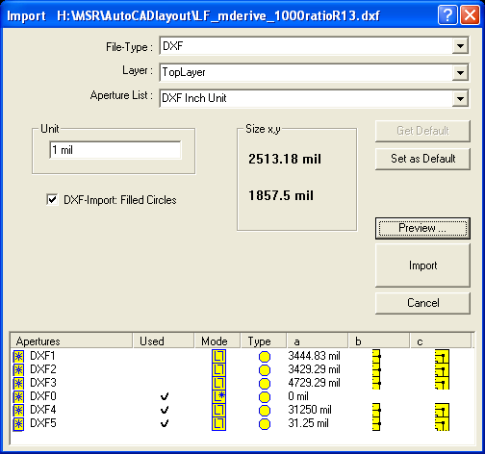

- Define the contour
- Go to “Edit/Contour Routing” in the menu
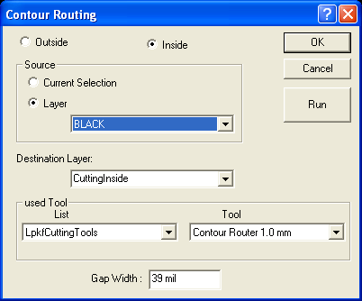
- Define the outside/inside contour routing by checking the radio button
- Choose Source layer using the drag down menu, select “Black” layer, which is the frame of the layout
- Click “Run” button
- The gray contour will show up
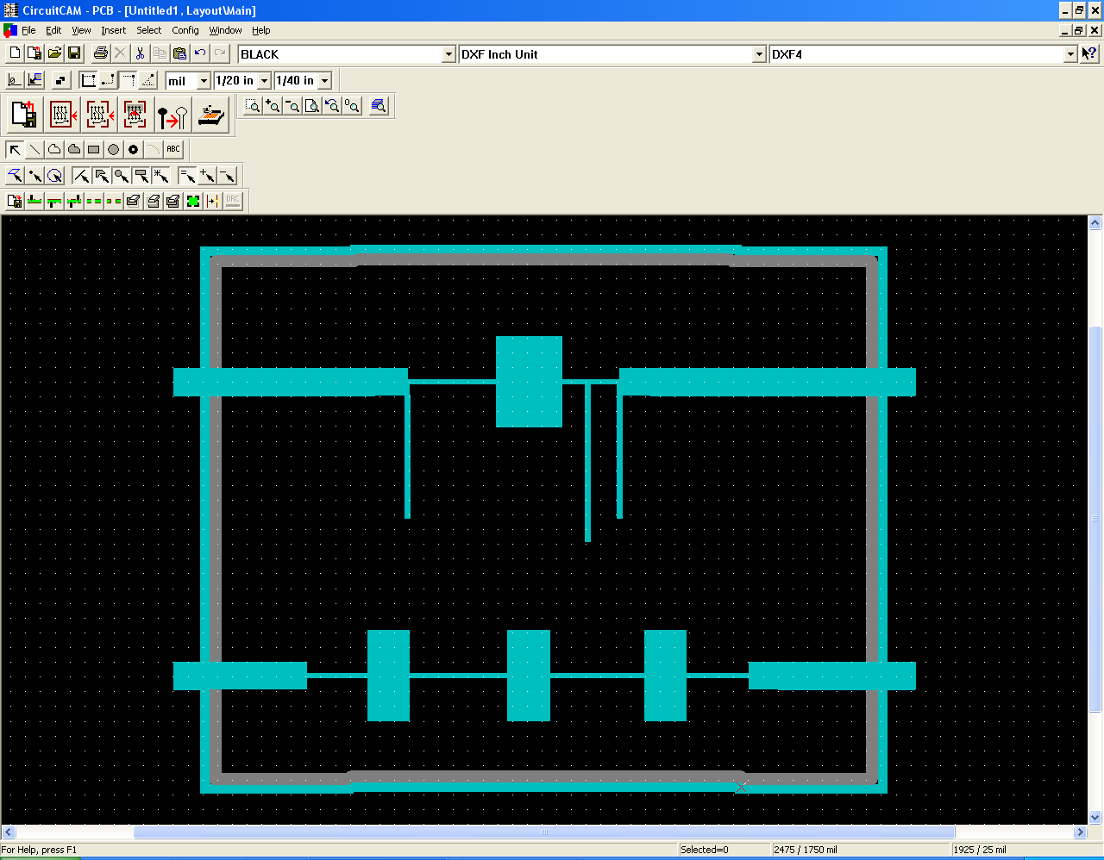
Contour line

- Define Insulate layer
- Go to “Edit/Insulate”, and the Insulate window will show up
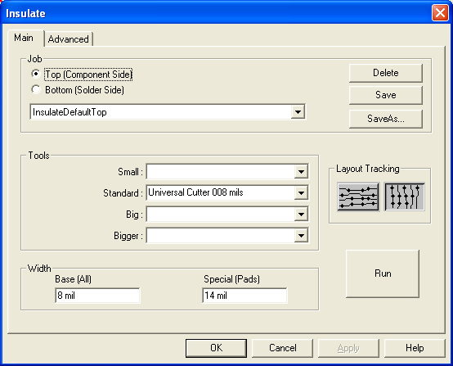
- Choose top/button layer that needs to be insulated. In this particular case, select “Top” because the AutoCAD file is imported as TopLayer
- Choose either Horizontal/Vertical Layout tracking by clicking the button in the “Layout Tracking” section.
- Click “Run” button
- The insulate pattern is highlighted.
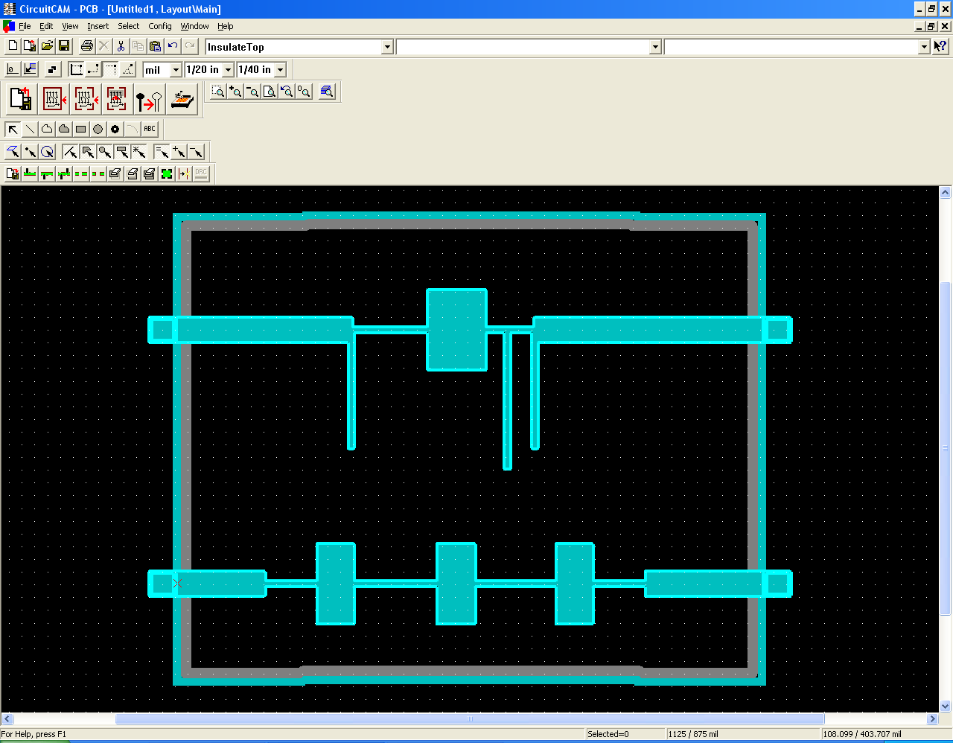
Insulate Pattern

Repeat step 4 to insulate all other layers for the PCB board if necessary.

- Insulate all layers by clicking “Insulate All Layers” Icon
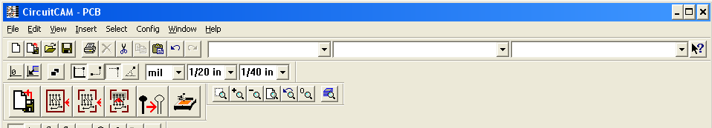

- Export the file into LPKFPlotter file by clicking the “Export” icon or going to “File/Export/LPKF/LpkfCircuitBoardPlotter”. The program will ask you to save the file in the .cam format and then a window will pop out saying that the file is exported
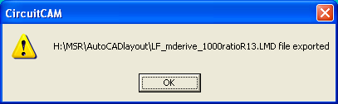

Now you are done with the CircuitCAM program. You should use BoardMaster to do the milling job.

