How to use Board Master to Mill a Circuit with LPKF 91S/VS

Peijung Tsai
You Chung Chung

University of Utah
Electrical and Computer Engineering Dept.

April 20, 2004
Table of Contents

1. Connections 3
2. Milling/Drilling/Cutting 4
2.1 Start BoardMaster 4
2.2 Setup the substrate 5
2.2.1 Fix the substrate on the LPKF bench 5
2.2.2 Install the milling/drilling/cutting tip 6
2.2.3 Adjust milling/drilling/cutting tip height 6
2-3 Start milling/Drilling/Cutting 6
2.3.1 Import .LMD file generated by CircuitCAM 6
2.3.2 Define material area 7
2.3.3 Start milling 9
How to use Board Master to Mill a Circuit with LPKF 91S/VS

1. Connection and Verification of LPKF Machine
This documents shows a connection between LPKF machine and computer.

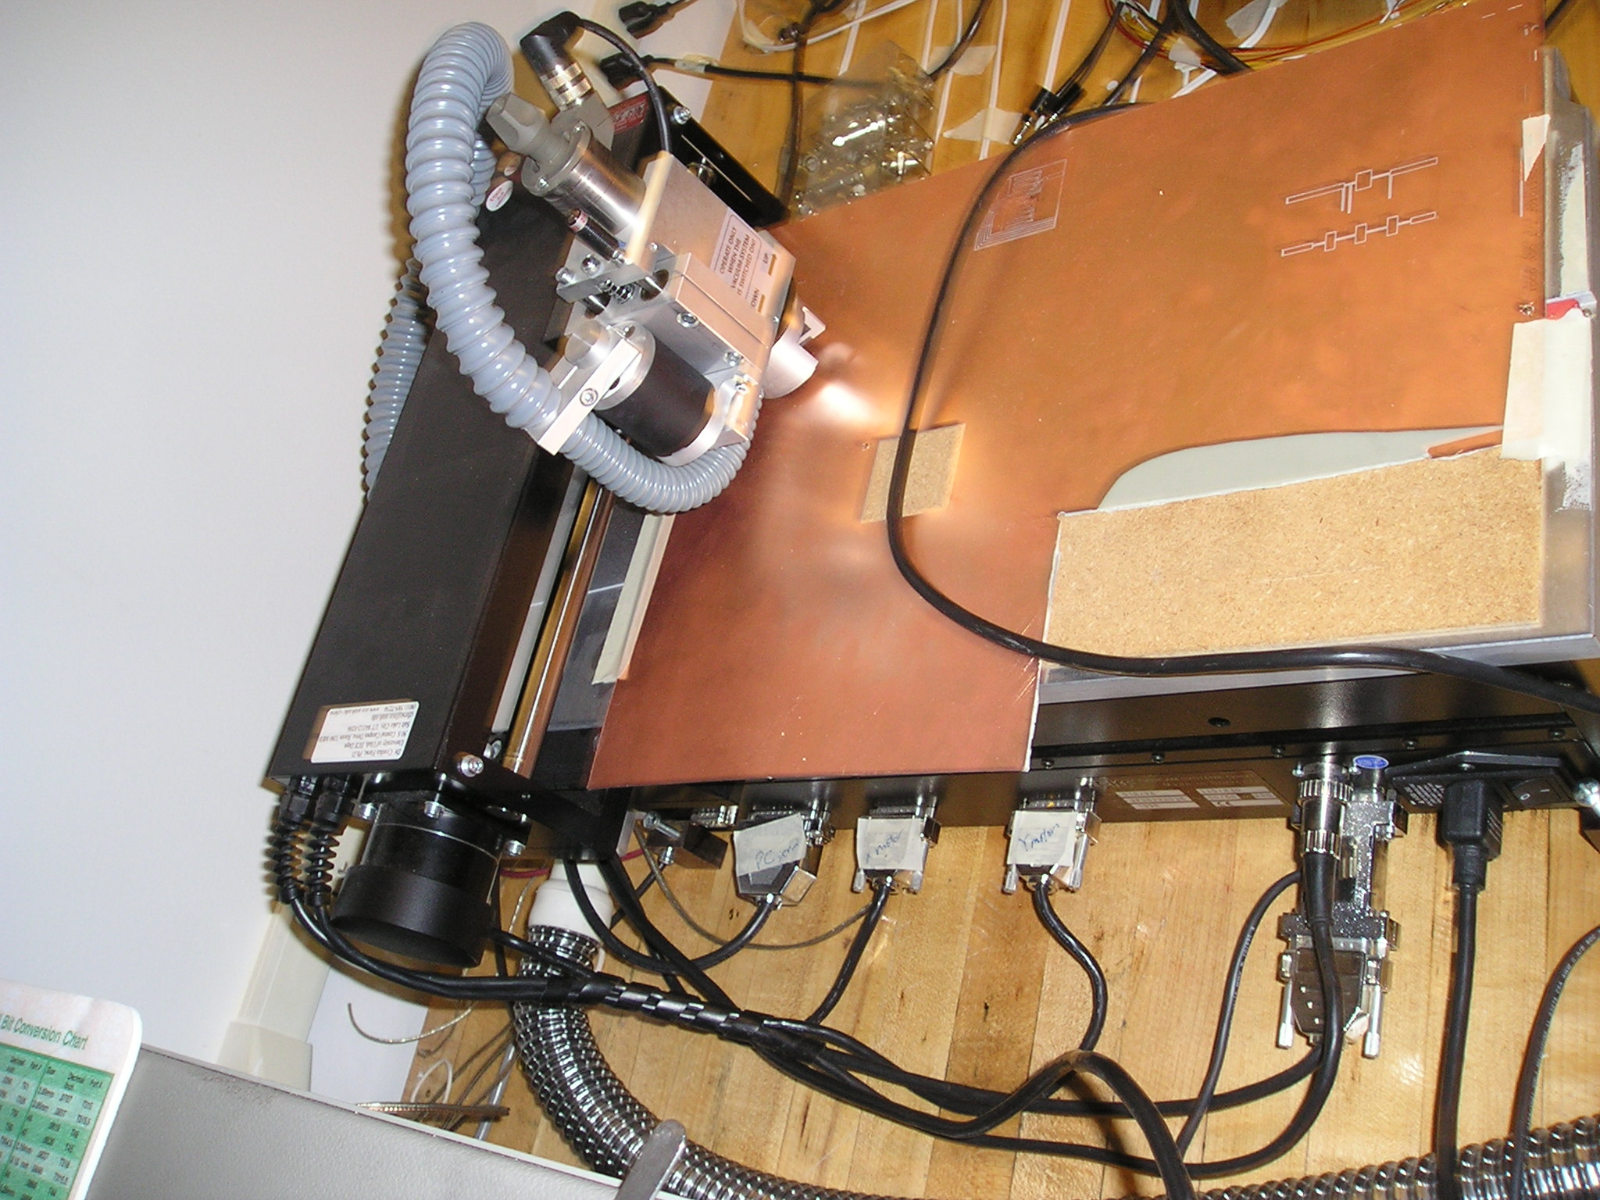
LPKF Protomat 91S/VS
Vacuum Connector
PC Serial Port

X-motor
Y-motor
Power cord
Figure 1 LPKF ProMat 91S/VS connection
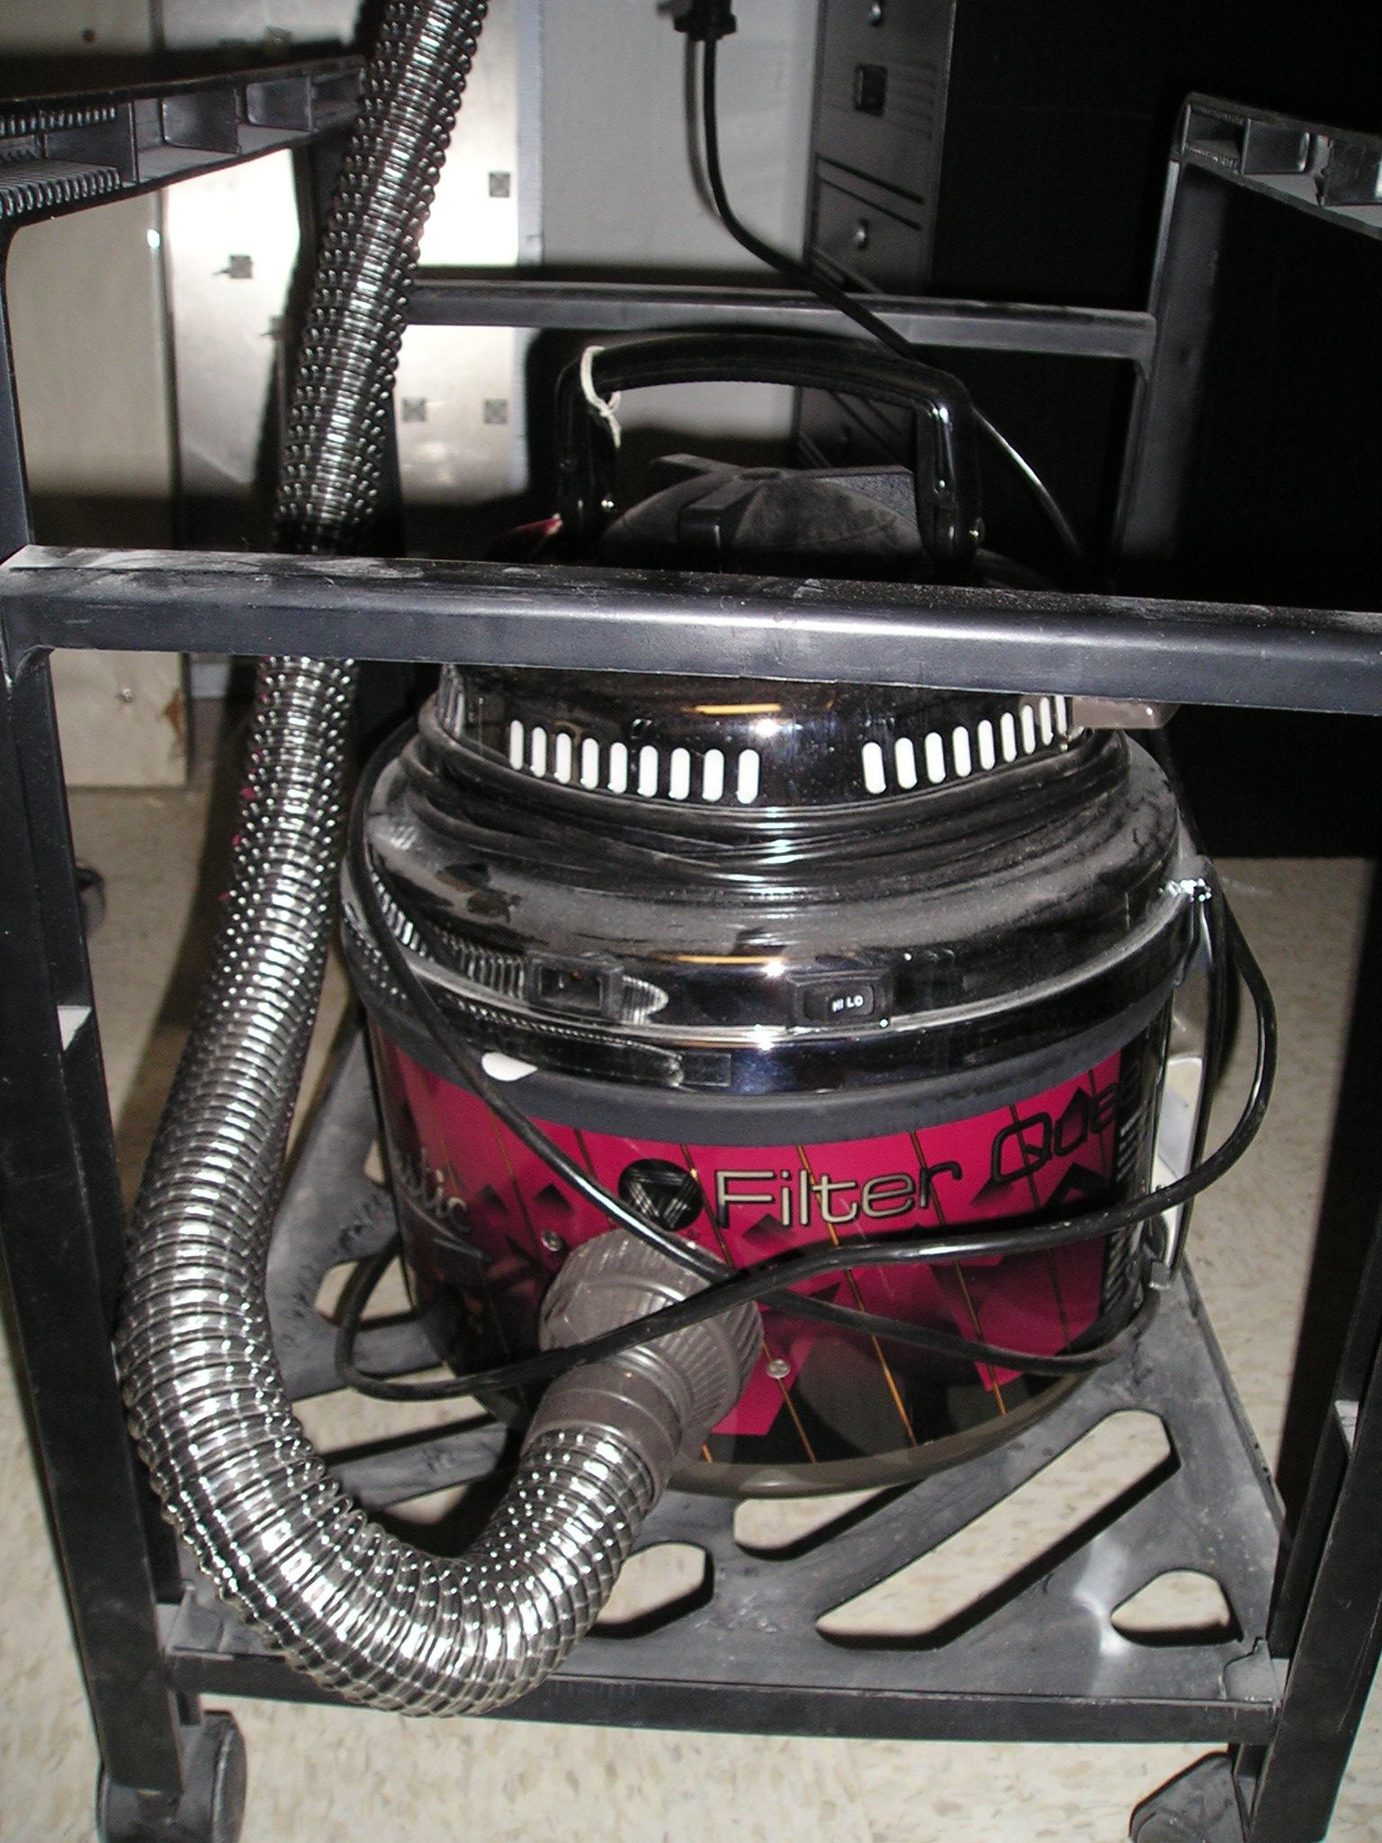Figure 2 vacuum connection
LPKF ProtoMat
AutoSwitch

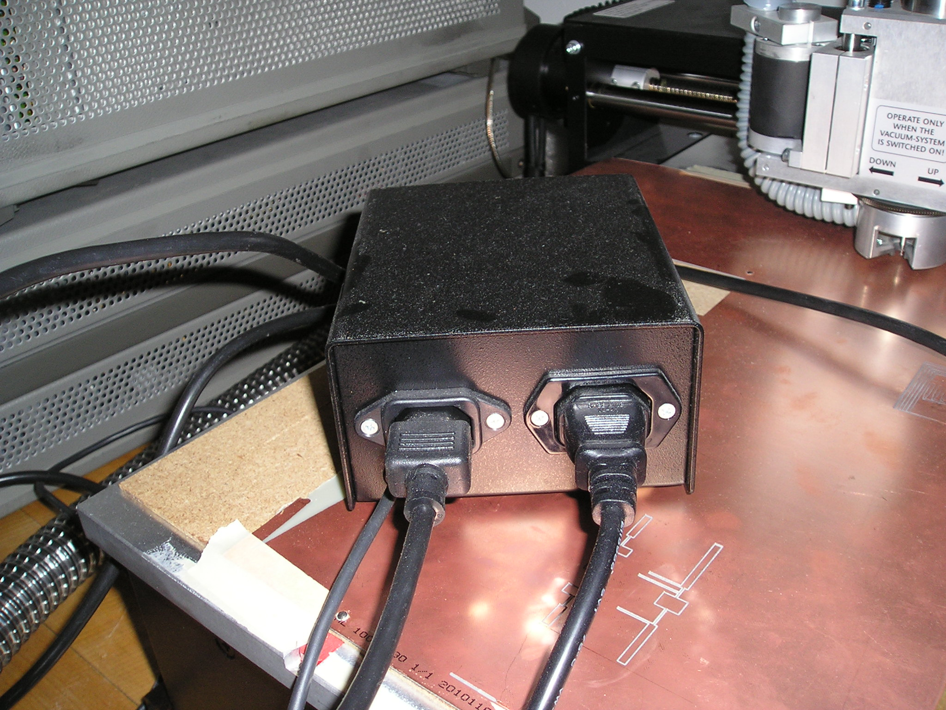
AutoSwitch
Power Outlet
Vacuum power
Figure 3 AutoSwitch connection

2. Milling/Drilling/Cutting
After generating a circuit cam file, a process and machine of milling a circuit is shown here.

Equipment/System requirement:
- LPKF 91S/VS milling machine
- Appropriate drilling/milling bits
- Board Master 3.0 program
- Milling data file generated from CircuitCAM
- Proper milling tips

  - Start to use BoardMaster program
Open the BoardMaster program by clicking “Start/Programs/ BoardMaster/BoardMaster 3.2”

A window will ask to switch the LPKF machine on. The power switch is on the back of the milling machine. Switch the power switch to “1” position and click “OK” in the window.
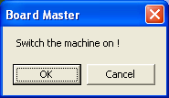

Another window will pop up to as the right figure below. It will disappear after the machine is on.
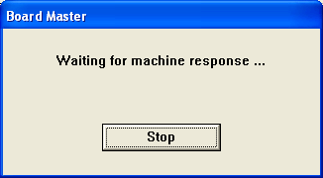

  - Set up the substrate

    - Fix the substrate on the LPKF bench

- Drill two 2.95mm reference holes at (15.00,0) and (295.00, 0.00) of the substrate. How to move the drill head, see “3. Define material data” part of the tutorial
- Use the aligner pins to fix the substrate with the LPKF bench
- Use paper type to type both edge of the substrate so that the substrate won’t move
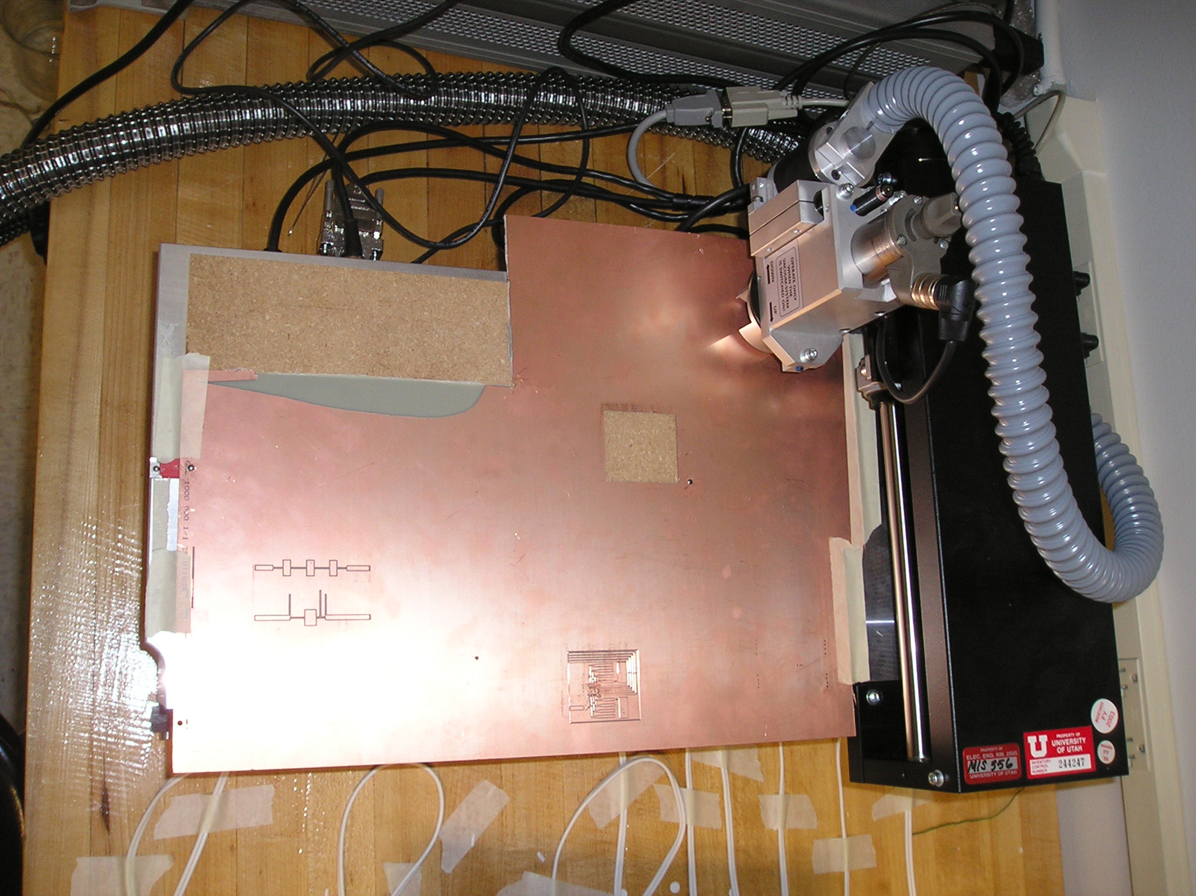
Paper type
Alignment pins

    - Install a milling/drilling tip

a. Move the motor head to “exchange” position by clicking “Go to/Exchange” and wait until the motor head stops moving
b. Use tweeter to pull the previous drilling/milling head
c. Install the desired drilling/milling head with appropriate height, see section 1.3

    - Adjust the milling/drilling/cutting tip height
a. Turn the limiter to the center position
b. Use the tweeter to adjust the drilling/milling head until your finger can barely feel the tip
c. Drill/Mill samples on unwanted portion of the substrate and adjust the height of the drilling/milling heat to the desire height by turning the depth limiter or using tweeters.

  - Start milling/Drilling/Cutting

    - Import the .LMD file generated by CircuitCAM
- Go to “File/Import/LMD LPR/Choose the file” you want to import
- If there is only a frame shown up, but not the pattern, change the milling/drilling phase to “Milling Top” or “Milling Bot” to see if the pattern shows up.
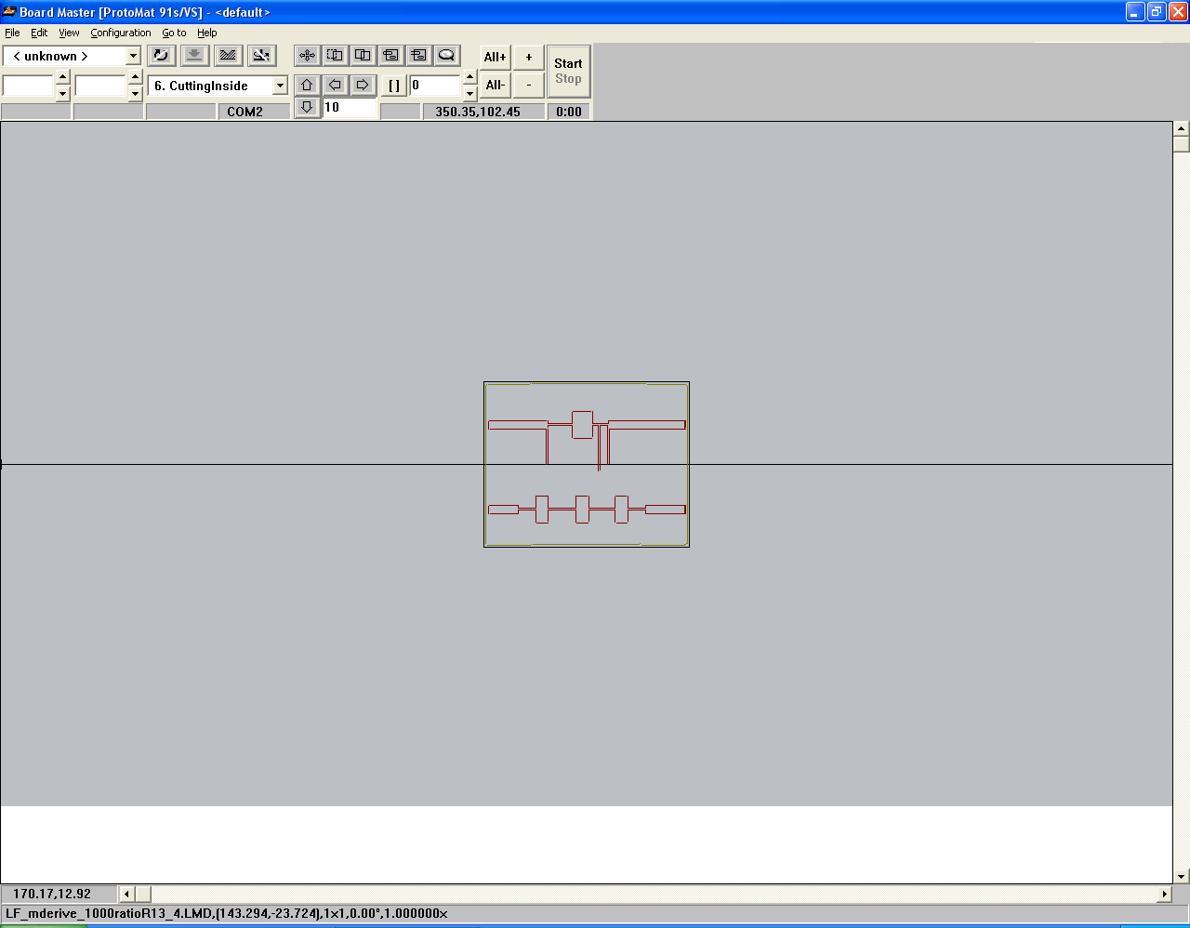

    - Define Material area
- The top view of the machine. Make sure that the material is fixed with the alignment pins and typed with paper types to prevent moving during the process
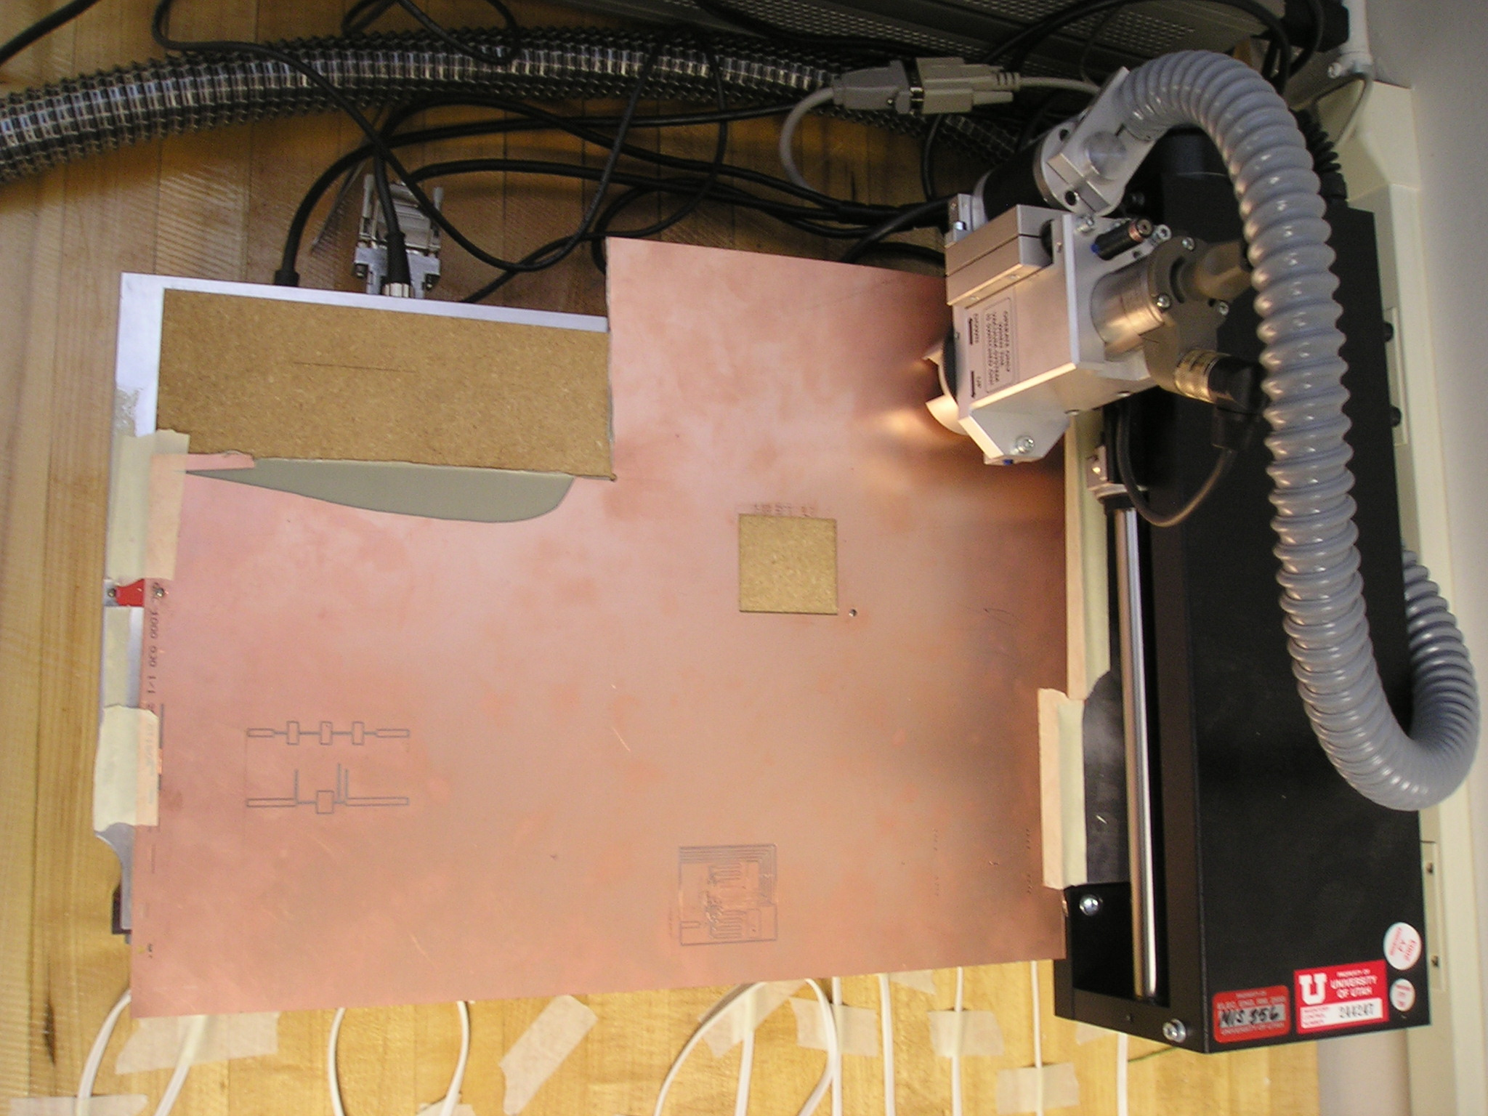
Alignment pins
- Move the machine around to the edge of the material using the step and arrows. The 4 arrows indicate the direction of the motor and the number indicate the distance to move
- 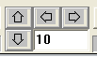
- Click “Configuration/Material/Set Low Corner”
- Move the machine to the diagonal edge of the material again using the cursor and steps. And then click “Configuration/Material/Set High Corner”
- A gray area indicates the material will show up in the window.
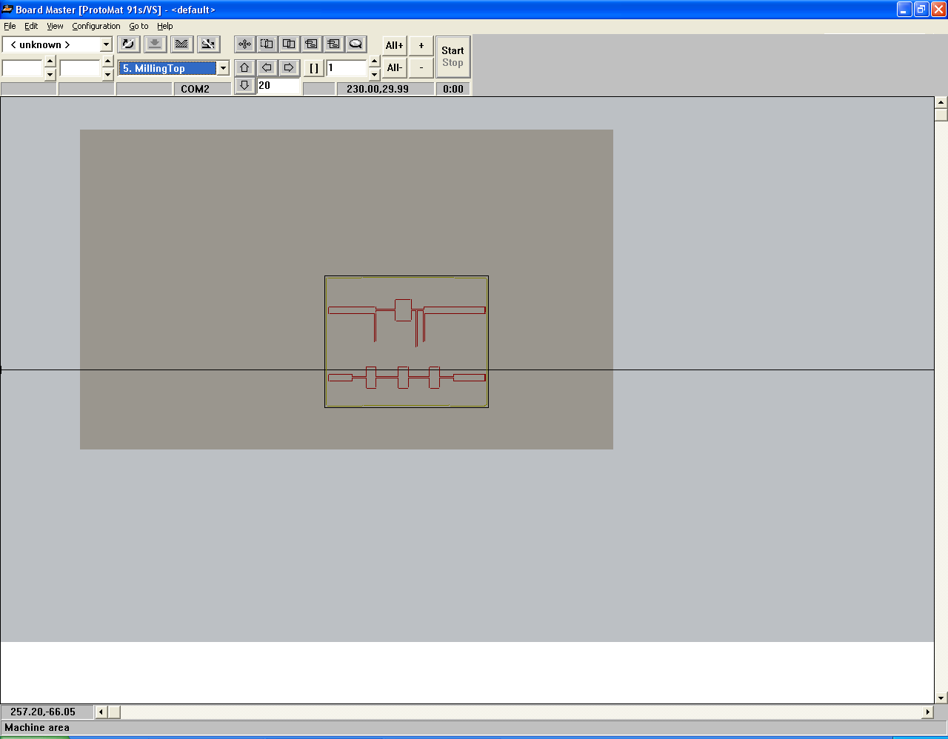
Material Area

Move the layout if necessary
- Click the move button, and drag the pattern to the appropriate place in the material
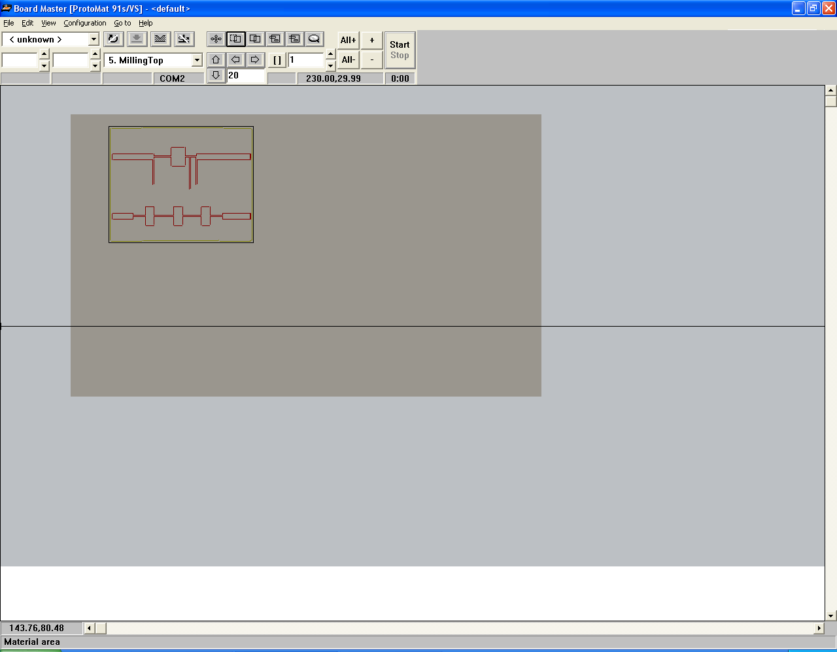
    - Start milling
- Choose the milling phase from the drag down menu
- Click “All+” button to select the entire pattern for the particular phase. The pattern will be highlighted as shown below
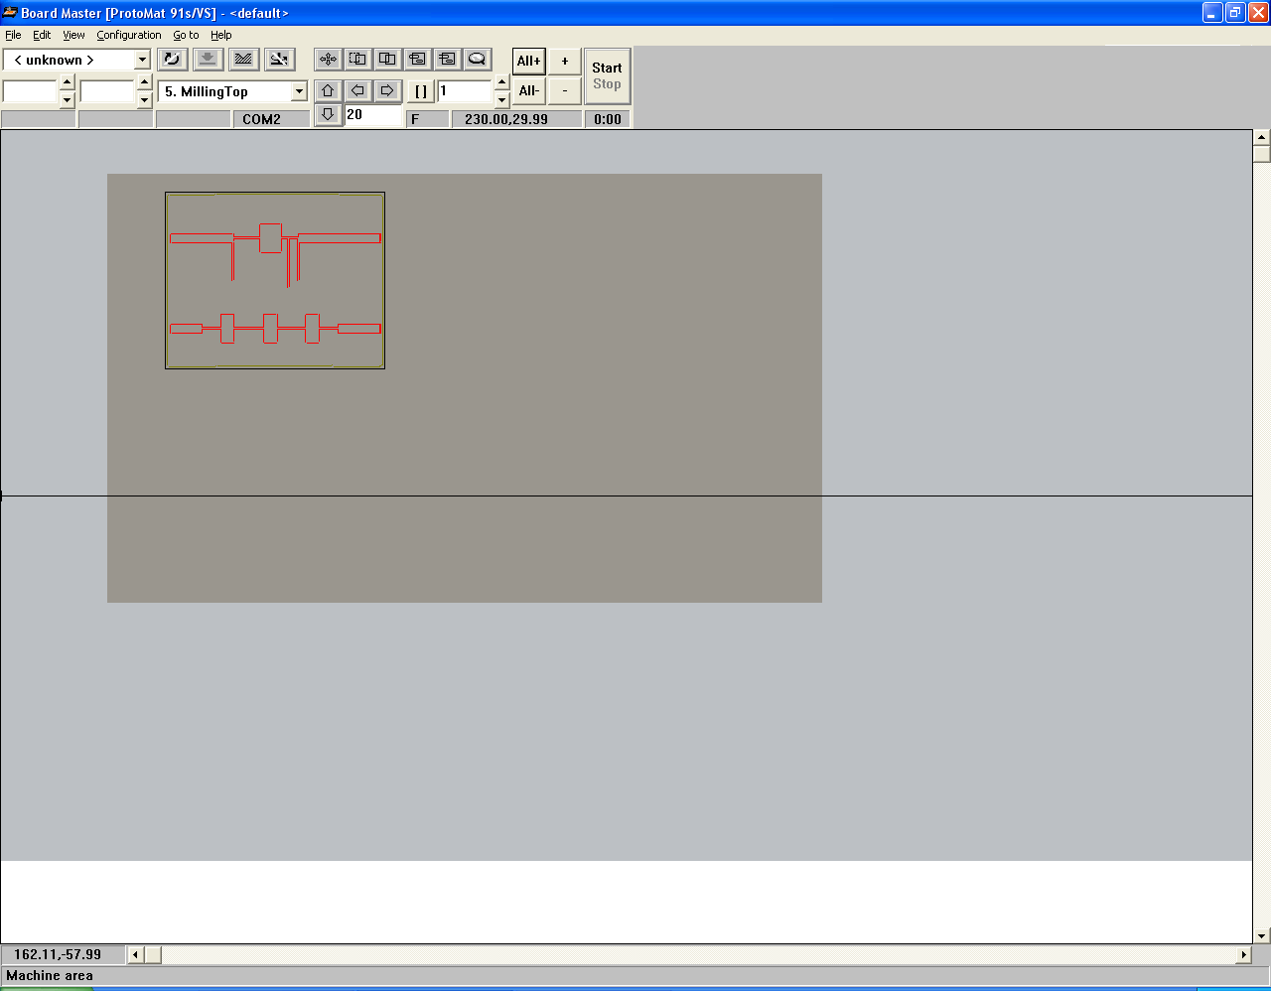

      - Select and change the appropriate drill/mill bit.

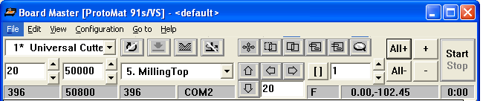

The motor will automatically moves to the exchange position, and you should attach the right tool to the motor.
      - Set up the motor to be automatic by clicking the “auto/manual” control button to make it auto control

Or you can use manual control to tune the motor on and off
Mill/Drill Selection
Motor On/Off

      - Click “Start” Button to start the 1st milling job.

Wait for the job to be done. Repeat step 2.2.3 for different milling/drilling/cutting phases until the whole board is done.

