Electrical Engineering is Fun!
battery
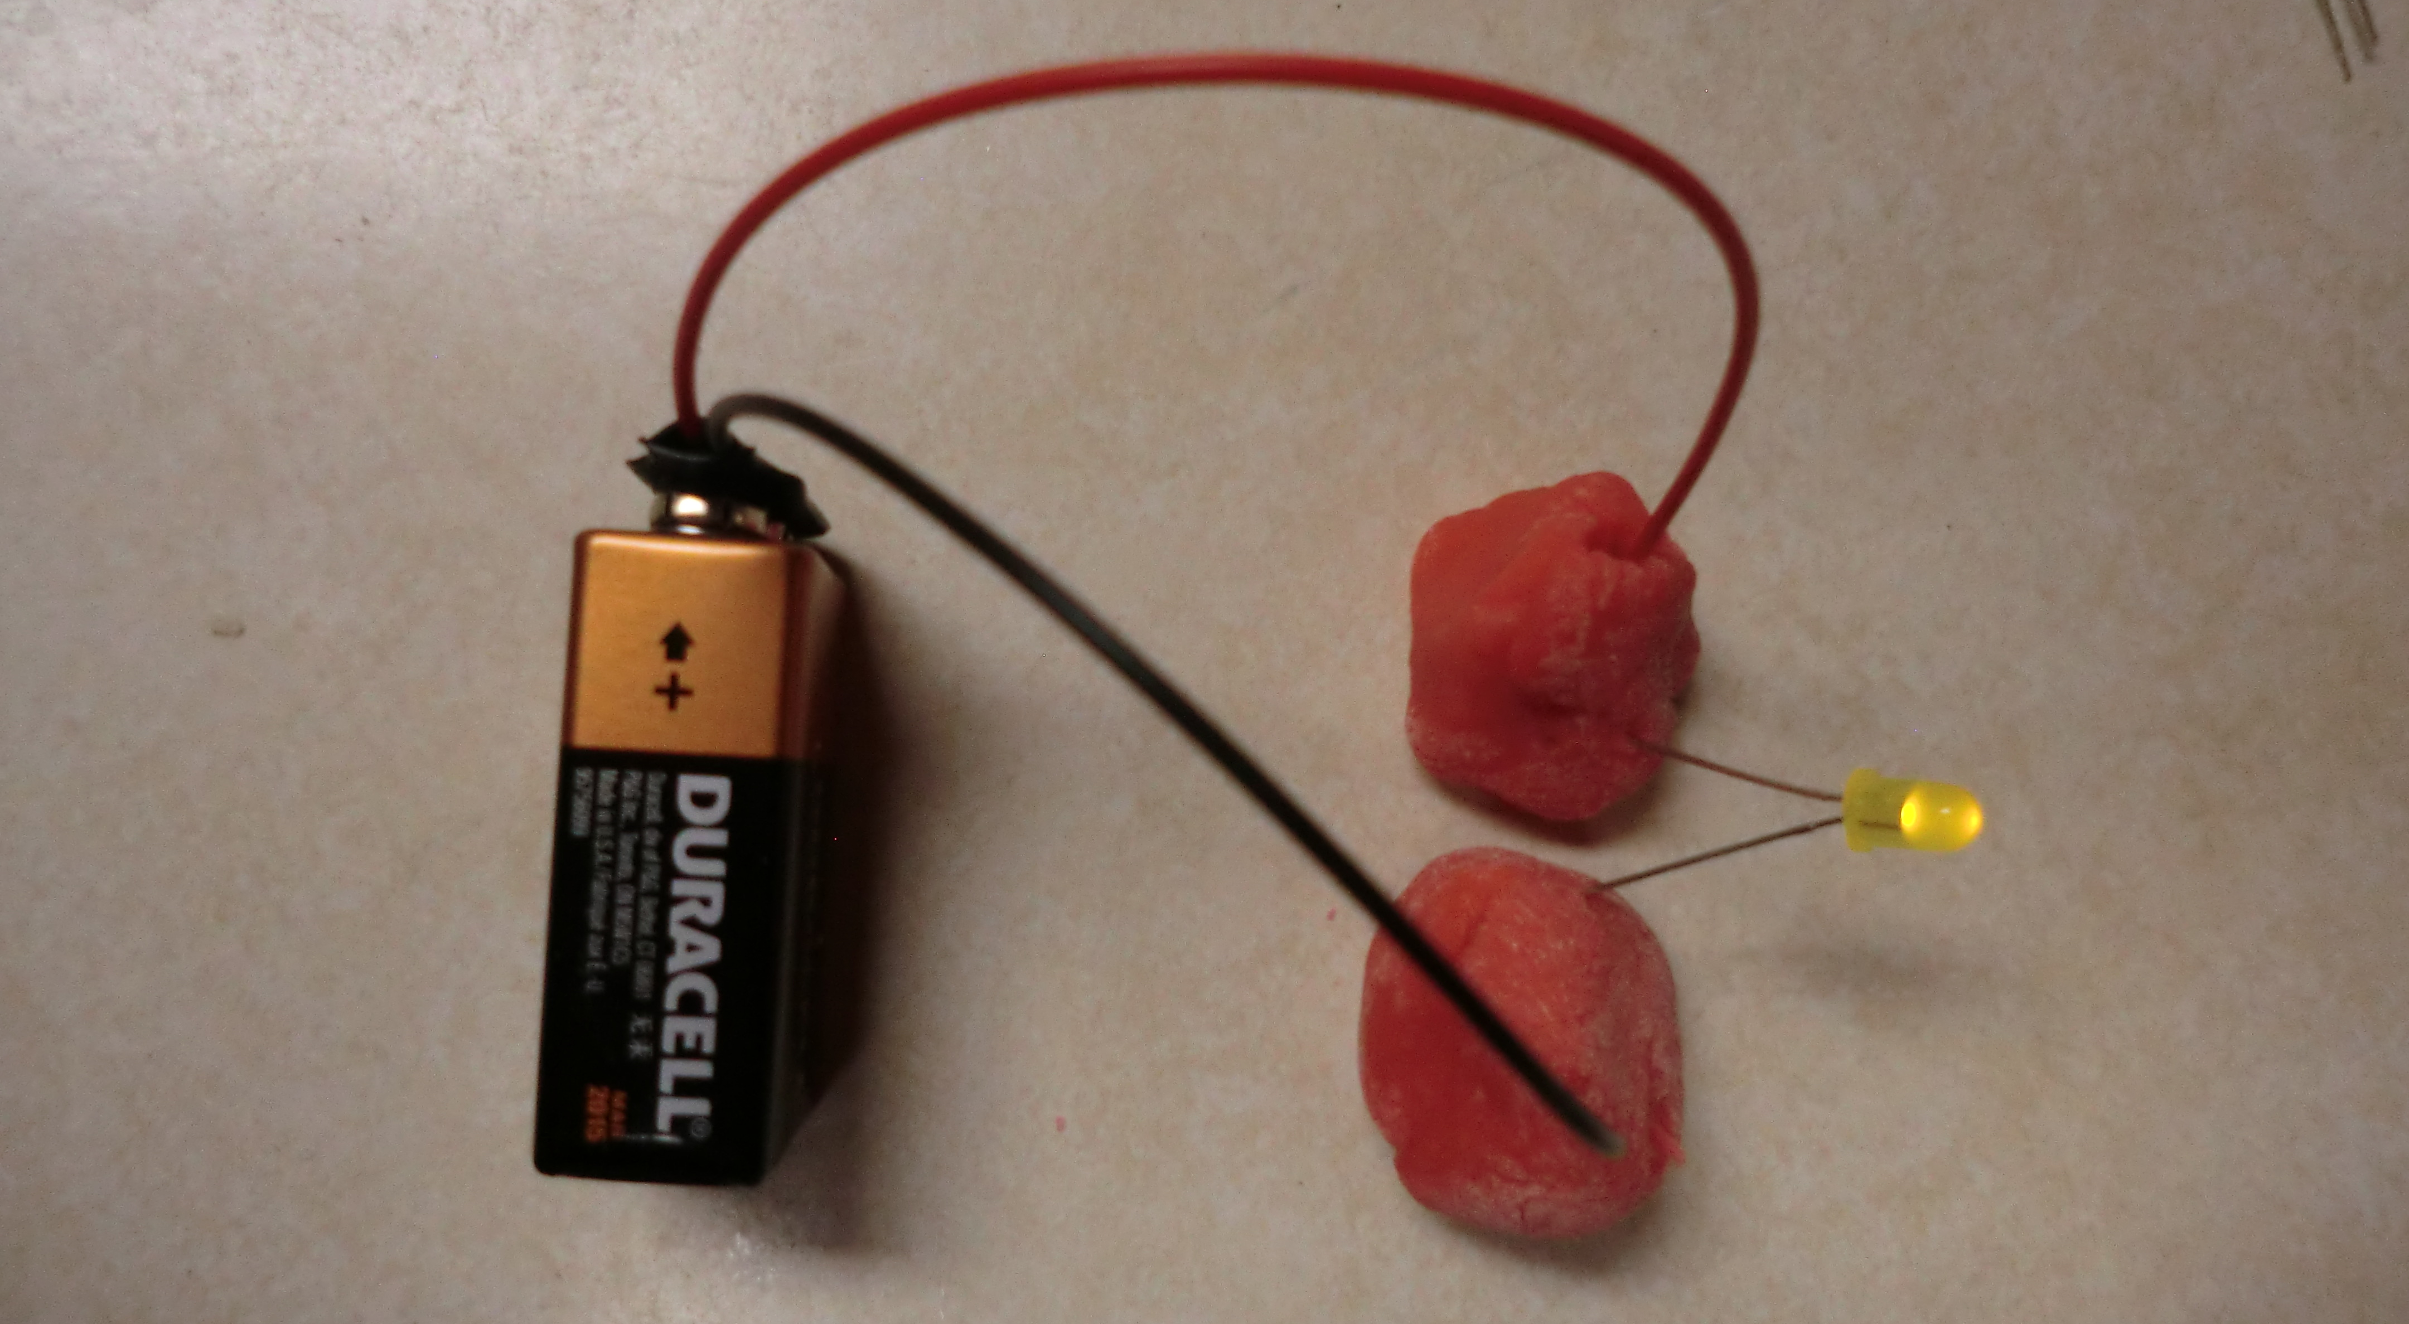
Red wire
black wire
LED
Long leg
Short leg
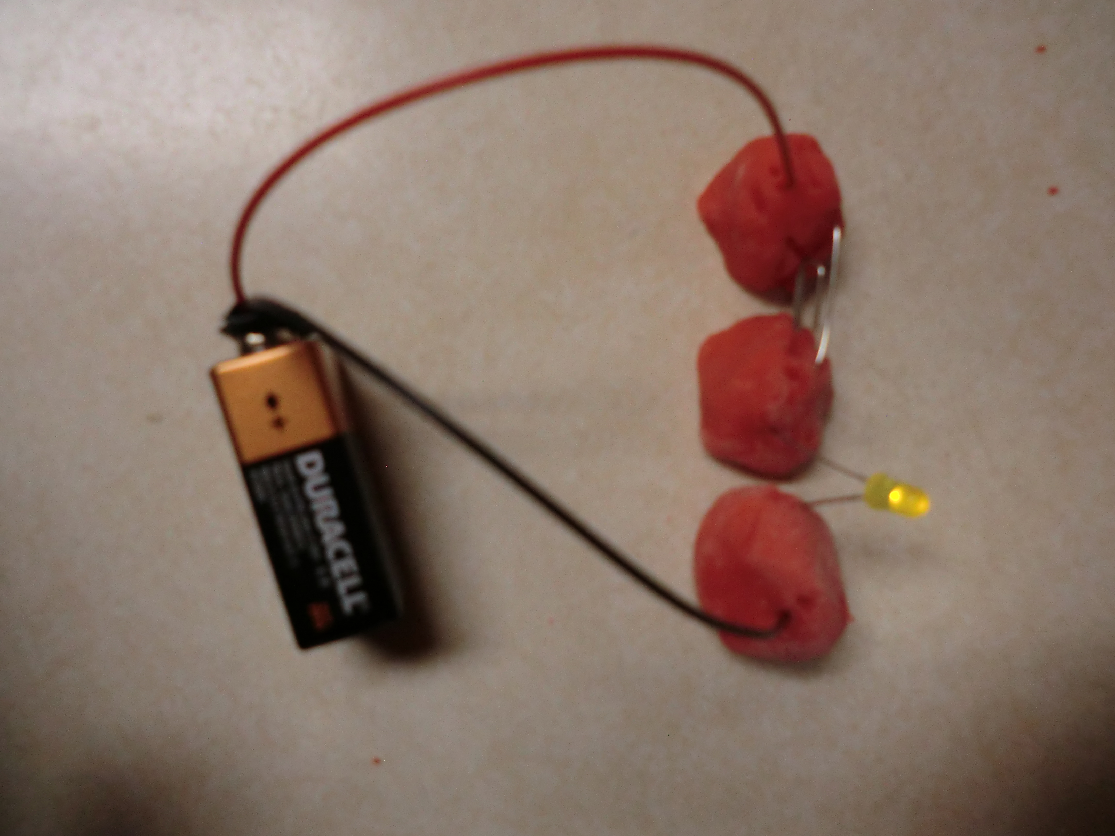
What conducts electricity?
Squishy Circuits -- http://courseweb.stthomas.edu/apthomas/SquishyCircuits/

