LAB REPORT WRITING (AND TEACHING!) MADE EASY

Abstract

This paper reports on a project to improve students’ ability to write better lab reports and assist teaching assistants (TAs) in grading reports in a consistent manner. A lab report teaching system was developed that includes lab report templates, teaching assistant instructions, grading rubrics, examples, peer review materials and instructions, and recommendations for quickly providing student feedback (grading). These materials were developed for project-based labs across the electrical engineering curriculum and utilize methods to write weekly lab updates that are combined into a final lab report, mimicking methods commonly used in industry. The technical writing information was adapted to all levels of complexity to help students from freshman through senior years. The system begins with instruction on writing very simple basic reports, and builds each year on previous knowledge and practices, to prepare students to later write complex reports. This system is designed to improve students’ understanding of labs (‘writing to learn’) in addition to preparing them for the communication intensive workplace. Detailed guidelines and grading rubrics are also included in this manual to instruct TAs on better and more consistent grading techniques. The amount of time spent grading is often a primary concern for engineering writing assignments, and this is often given as a reason for not requiring advanced writing assignments in engineering classes. Guidelines for checking both lab books and formal lab reports help improve TA training and grading consistency, reducing student complaints. Although this system was designed for an electrical engineering program, it can also be adapted to other technical fields and used for various scientific lab reports.

Improving Teaching and Learning

This paper describes a project focused on the departmental goal to improve students’ ability to write excellent lab reports and assist teaching assistants (TAs) in grading reports in a consistent manner. It was developed to help train new TAs to continue the success of a new curriculum shift towards project-based learning¹. This new curriculum includes more writing to help students process what they are learning and includes project-based labs to help students understand the relation between individual and system-level concepts.

New Teaching System

In order to train TAs, a lab report teaching system was developed and made available through a website. This system included TA instructions, resources for conducting a lab overview, lab report templates, grading rubrics, examples, peer review materials and instructions, and recommendations for quickly, but effectively, providing students with constructive feedback. This section describes each of these resources in more detail.

TA instructions are essential to having successful TAs. Answers to commonly asked questions were compiled and included on the website to provide TAs with all the information necessary to prepare for and conduct lab sessions. Some of the instructions may be department or university specific, but like the rest of the material in this system, these can be adapted to the procedures of various departments.

A lab overview was given during the first week to help students understand how each individual lab they would be doing throughout the semester related to the project as a whole. During this Lab 0 overview, the students were asked to write the introduction to the final report. While this might seem a bit backwards (write the ending before you have even started!), the introduction to a system-level report normally describes the system, motivation for the system, and how all of the individual parts fit into the system. This classic example of ‘write to learn’ required the students to conceptualize and then write about the system project for that semester. Material was provided on the website to help the instructor and TAs conduct the Lab 0 introductory lab, where an overview of the lab project and expectations for the Weekly and Final Report were explained. The students were assigned to read a technical article that showed the importance of the project. The TA also explained an overview of how the project is broken down into individual labs, familiarizing students with the lab instructions and rubrics, showing students where to find lab report checklists and templates. In the end, the students wrote the introduction for their Final Report and conducted a peer review of these introductions. Later, when the students were completing their final reports, they were asked to go back and adjust their introductions as needed, but most found their initial introductions were pretty close to their final form.

Lab report templates were provided for both independent labs and project-based labs. Each section includes descriptions of what content should be included as well as step-by-step instructions on how to format the reports, as seen in Figure 1 and Figure 2 . These were found to be an excellent resource to help students understand the format and content that are expected for lab reports, and also provide a consistent format to make grading easier for TAs. We observed that when students are given a template, they immediately download the template, and begin using it. This was not necessarily true of instructions! By combining the instructions into the template, the students had to delete the instructions (hopefully reading them in the process) before typing their own work. This form is being used for many professional templates, including those for this ASEE conference!

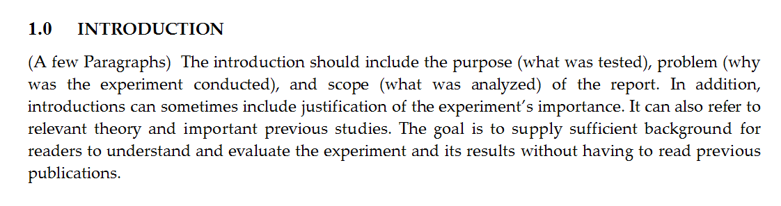
Figure 1: Sample Introduction¹

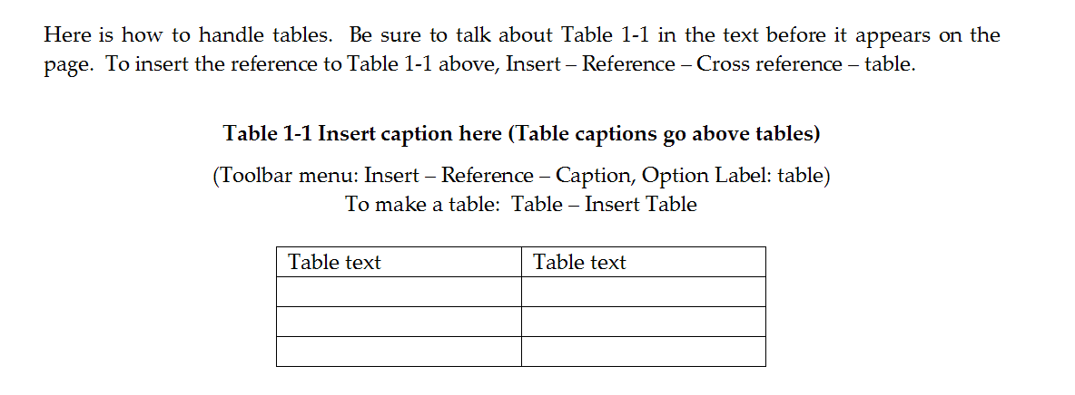
Figure 2: Sample Table Formatting¹

Sample grading rubrics were provided for weekly lab books and reports, as well as the final report required for project-based labs. The rubrics are broken into sections, then list essential components and how many points each component is worth, as seen in Figure 3. The students were given the grading rubrics along with the lab handouts. The content listed in the rubric is also listed in the report templates, ensuring that students include the complete content in their report. Previous lab reports (prior to use of the templates and rubrics) had major problems with content. Most often students left out major sections of important engineering content and received poor grades as a result. Specifically telling students what content is needed through the use of templates and rubrics ensured better content in later reports, as expected. We are not yet certain if students are actually learning to judge what content they should include in their reports, or not. We do know that many students have chosen to continue using the templates outside of the classes where they were originally required. Other resources to help teachers and their assistants in creating rubrics were also included on the website, such as a generalized rubric and instructional rubric websites.

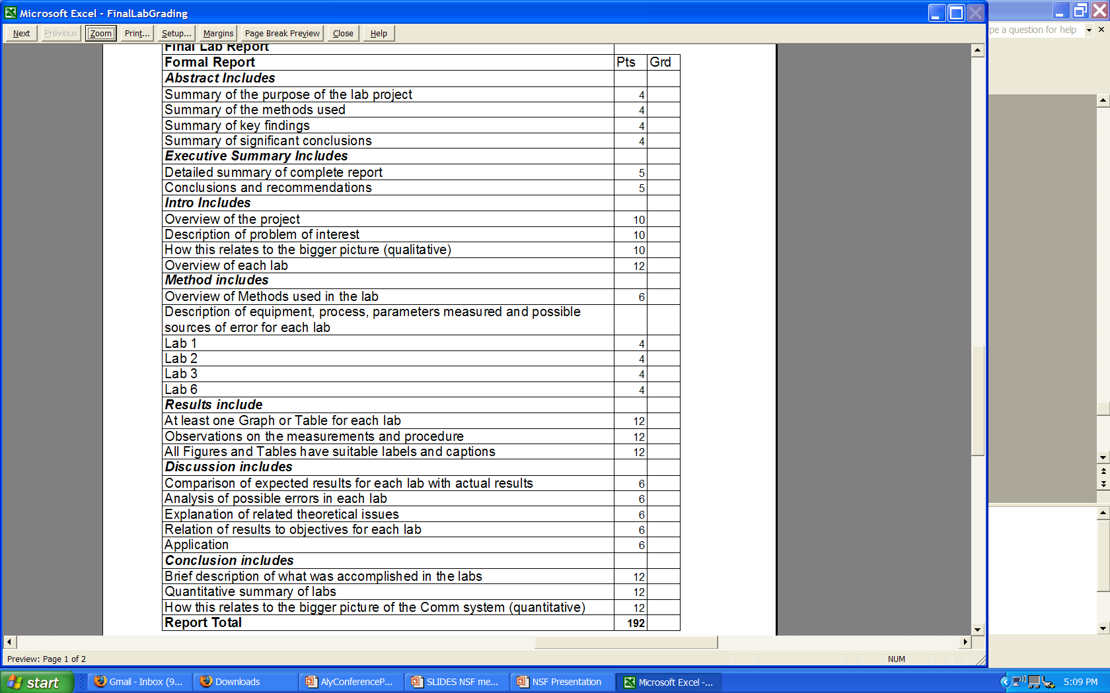

Figure 3: Sample Sections from Final Report Grading Rubric¹

Examples of excellent student lab books and reports were collected and scanned in with permission to provide TAs and students with a baseline of what was considered good work. These were not available for the previous year and are a recent addition that we are hoping will help students reach a higher level of report writing.

Constructive feedback involved more than just letting students know whether they were right or wrong, but required details on what to work on, giving them scaffolding for improvement. This was accomplished through a few avenues. At the end of the report rubrics, a writing feedback form was provided so the TA could give individualized feedback without the student losing points, as shown in Table 1. This allows the TA to point out general problems, without having to grade the writing meticulously. Peer reviews were also found to be very beneficial to students and helped them think about what they were writing. Additional instructions on how to conduct peer review sessions were also provided on the TA website. The major aspect we found to be important in peer reviews was giving guided feedback (again through the use of a rubric) so that students knew what they were looking for. For instance, if students were asked to include information on how the individual lab related to the overall project, the peers were asked to circle or number the sentence(s) that included that information. Students were often surprised when their peers could not find information they thought they had included, which meant their writing was not as clear as they thought it was. Many made changes for better clarity after the peer review.

Table 1: Writing Feedback Form for Final Lab Reports¹
Writing Feedback | Needs Work
Writing flow
Spelling
Grammar
Past tense
Passive voice
Equation formatting
Clarity of ideas

Constructive feedback was also helpful to the TAs to improve their explanations in lab. This was accomplished by having students in freshman and sophomore labs research and give short presentations on “muddy points,” or points they had not understood in the previous week’s lab³. This was also used as a way for students to have a short experience speaking in front of the group.

Results

All materials used were first tested in the lab setting and approved by individual faculty. They were then adopted by multiple faculty, or adapted as needed for individual classes. These materials were developed for project-based labs across the electrical engineering curriculum and utilize methods to write weekly lab updates that are combined into a final lab report, mimicking methods commonly used in industry. The system begins with a lab overview, which not only helps the students in the lab, but also helps improve their understanding of concepts in class. Students are able to relate what they are learning in class to what they needed to accomplish in lab². The technical writing information was adapted to all levels of complexity to help students from freshman through senior years. It includes instruction on writing very simple basic reports, building each year on previous knowledge and practices, to prepare students to later write complex reports. This system improves students’ understanding of labs (‘writing to learn’) through the ability to explain labs in addition to preparing students for the communication intensive workplace. Detailed guidelines and grading rubrics have also been included in this web-based manual to instruct TAs on better and more consistent grading techniques. Methods for reducing the time required to grade the written labs were also provided. Guidelines for checking both lab books and formal lab reports help improve TA training and grading consistency, reducing student complaints. Although this system was designed for an electrical engineering program, it can also be adapted to other technical fields and used for various scientific lab reports.

Future Adaptations
This writing method is now being integrated into most/all of the electrical engineering laboratory classes. We hope to see significant improvements in writing as the students progress through multiple years of this program. At present, significant improvements in individual students’ writing was observed over a single semester, but we have not been able to follow students through multiple years. We have also implemented our own department-wide writing class and will be developing templates for a number of other types of writing. Finally, we will be experimenting with better ways to have TAs provide electronic feedback to the students, and tracking the changes they make to their writing as a result of these comments.

Bibliography

- Alyssa Magleby, Cynthia Furse. “Improving Communication Skills Through Project-Based Learning.” Submitted for publication.
- Cynthia Furse. Personal Communication. January 2008.
- http://www.ece.utah.edu/~cfurse/CLEAR/

